Mandatory Disclosure

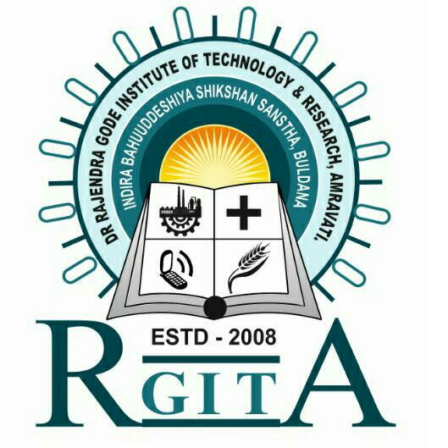

Submitted by

Dr.Rajendra Gode Institute of Technology & Research, Amravati
University – Mardi Road, Amravati. 444602
Maharashtra
Website: www.drgitr.com Email: principal_coe@rediffmail.com
Ph. No. (0721)-2970275 / 2970347
Fax No. 0721-297025
Mandatory Disclosure:-Updated on 05/04/2024
AICTE File No : - Western/1-36449606512/2023/EOA
Date & Period of last approval. : - 02/06/2023 Period: 2023-2024
NAAC : - Grade “A”

1) Name of the Institute:-Dr.Rajendra Gode Institute of Technology & Research, Amravati
Address of the Institution :-University – Mardi Road, Amravati.
City & Pin Code :-Amravati – 444602
State :-Maharashtra
Satellite view of Collage:-
Phone Number with STD Code : - (0721)-2970275 / 2970347.
Office Hours at the Institution :-10.45 am to 6.00 pm
Academic Hours at the Institute :-11.00 am to 05.00 pm
Email : - principal_coe@rediffmail.com and
principal@drgitr.com
Web Site :-www.drgitr.com
Nearest Railway Station (dist in Km) :-Amravati, 11km
Nearest Airport (Dist in Km) :-Nagpur, 150
Type of Institute :-Private- Self Financed
2) Name of the organization Running the institution:- Indira Bahuuddeshiya Shikshan
Sanstha
Type of the organization : - Society
Address of the organization : - Dr. Gode Niwas, Chikhali Road, Buldhana, Maharashtra, Pin-443001
Registration date :-1986
Website of the organization : - www.drgitr.com

3) Name of Principal : Dr. Arun V Parwate
Exact Designation : Principal
Phone No. : (0721)-2970275 / 2970347
Email : principal_coe@rediffmail.com
Highest Degree : Ph.D.
Field of Specialization : Environmental Engineering

4) Name of the affiliating University:- Sant Gadge Baba Amravati University, Amravati

Address : Tapovan Road, Amravati
Website : www.sgbau.ac.in
Latest affiliation period : 2023-2027

GOVERNING COUNCIL BOARD MEMBERS
5) C.D.C
Sr. No. | Name | Designation
1 | Shri. Yogendraji.R. Gode | President
2 | Ms. T. Y. Gode | Management Representative
3 | Dr. R. M. Deshmukh | Member H.O.D.
4 | Dr. S. C. Jirapure | Teaching
5 | Prof. A. A. Shahade | Teaching
6 | Dr. A. P. Jadhav | Teaching
7 | Mr. S. R. Charpe | Non-Teaching
8 | Dr. H. H. Dike | Member Research
9 | Shri. S. R. Meghe | Member Education
10 | Shri. S. S. Jadhao | Member Industry
11 | Ms. S. A. Gomase | Member Alumnus
12 | Dr. P. B. Nagarnaik | IQAC Coordinator
13 | Dr. A. V. Parwate | Member Secretary

6) Executive Committee
Sr. No. | Name | Designation
1 | Shri. Yogendraji R. Gode | President
2 | Miss S. H. Dike | Vice President
3 | Ms. T. Y. Gode | Secretary
4 | Smt. U. R. Gode | Treasurer
5 | Smt. I. H. Dike | Member
6 | Dr. S. P. Thorat | Member
7 | Shri. Yogendraji R. Gode | President

7) Departmental Heads
Sr. No | Name of member | Designation
1 | DrA.V.Parwate | Principal
2 | Dr. D.Y.Patil | Head of CSE Department
3 | Dr. S.G.Jirapure | Head of Mechanical Department
4 | Dr. A.O.Vyas | Head of EXTC Department
5 | Dr. P.B.Nagarnaik | Head of Civil Department
6 | Dr. S.D.Thakre | Head of Fist Year Department

8) Anti Ragging Committee
Sr.No | Name | Designation | Mobile No
 | Dr. A. V. Parwate | Head of Institution | 7402414100
 | Mr.R.M.Bhoyar | Civil Administration | 0721-2673023
 | Mr.R.M.Manekar | Police Administration | 0721-2552600
 | Mr.Devendra A.Thakare | Local Media | 8329705183
 | Mr.Datta Prasad Dhawade | Non Govt. Organization in youth  activity | 8087773759
 | Dr. S. D. Thakare | Representative of faculty member | 9403625974
 | Prof. A. A. Shahade | Representative of faculty member | 8888137777
 | Prof. K. M. Pimple | Representative of faculty member | 9763758241
 | Mr. Ajabrao Mapari | Representative of Parent | 9767754945
 | Ms. Revati Patil | Representative of student belonging  to freshers category | 7709454427
 | Mr. Prathamesh Raut | Representative of student belonging  to freshers category | 8767750365
 | Mr. Atharv Zalke | Representative of student belonging  to senior student | 9096996445
 | Mr. Abhishek Dharmale | Representative of student belonging  to senior student | 9503371055
 | Mr. S. R. Charpe | Non Teaching Staff (Male) | 9404872009
 | Ms. A. M. Hate | Non Teaching Staff (Female) | 9823124339
9) Ladies Grievance Committee
Sr.No | Name Of Member | Designation | Mobile No
 | Prof.Ms.K.M.Pimple | Chairperson | 9763758241
 | Prof.S.C.Tawlare | Female teacher | 7798512539
 | Prof.V.A.Fulari | Male teacher | 8380008549
 | Mr.Rajendra V.Shende | Male non teaching | 9403265866
 | Ms.A.M.Hathe | Female non teaching | 9423124339
 | Mr.S.G.Bhise | NGO | 9423427823
 | Mr.Y.R. Kalinkar | Male Student | 9511639516
 | Ms.B.N.Tale | Female Student | 9970446220
 | Adv.Ms.Urwi keche | Lady Lawyer | 9503182513
10)SC/ST Committee
Sr.No | Name Of Member | Designation | Mobile No
 | Dr.M.R.DHARME | Chairperson | 9422916240
 | PROF.K.M.PIMPLE | Female teacher | 9763758241
 | PROF.A.R.BIJWE | Male teacher | 9975363104
 | PROF.K.K.PADGHAN | Male teacher | 9970396520
 | Mr.D.A.MESHRAM | Male non teaching | 7822019471
 | Mr.P.B.INGLE | Male non teaching | 9689622852

11) STUDENT COUNSELLOR COMMITTEE
Sr.No | Name Of Member | Designation | Mobile No
 | Dr.RAVINDRA DESHMUKH | Chairperson | 9403304392
 | Prof.Y.B.Bhagat | Female teacher | 9373457693
 | Prof.A.D.Nakhale | Female teacher | 9370415683
 | Prof.S.D.Thakare | Male teacher | 9403625974
 | Prof.P.R.Wankhade | Male teacher | 8380008576

12) Internal Quality Assurance Cell
Sr. No. | Name Of Member | Designation
1. | Dr. A. V. Parwate | Principal | Chairman
2. | Dr. P. B. Nagarnaik | Head, Civil Engg Dept | IQAC Coordinator
3. | Dr. A. O. Vyas | Head, EXTC Engg Dept | Member
4. | Dr. D. Y. Patil | Head, CSE Dept | Member
5. | Dr. S. D. Thakare | Head, First yr Engg Dept | Member
6. | Dr. S. C. Jirapure | Head, Mech Engg Dept | Member
7. | Ms. S. A. Gomase | Engg Dept, Alumni representative | Member
8. | Shri Sanjay Jadhav | Industry Expert | Member

11) Organization Chart
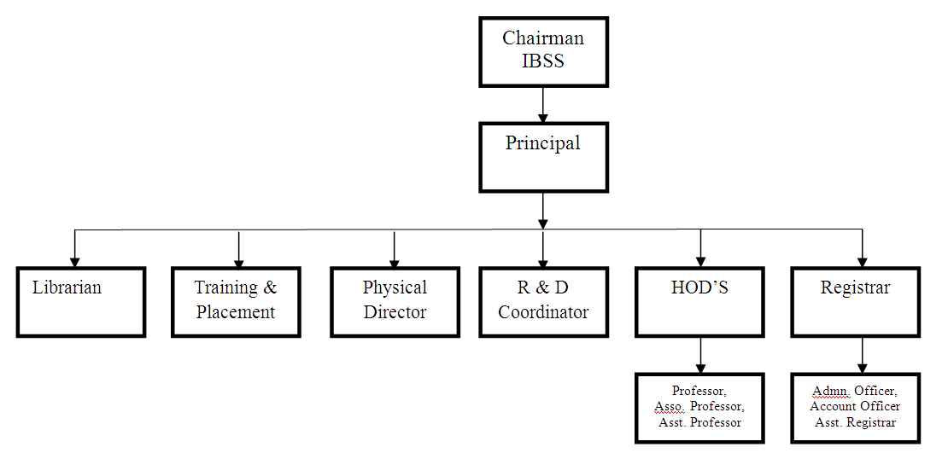

12) Student feedback mechanism on Institutional Governance/faculty Performance
: Online Feedback mechanism.

13) Grievance redressal mechanism for faculty, staff and students.

: Different Committees (e.g. Women’s Grievance Committee, Staff grievance Committee) are formed to settle the grievances.

Programme Information (in detail)
Sr. No | Programme Information
1 | Name | B.E M.E Diploma
2 | Approved Intake First Year | 240 48 180
3 | Duration | 4 years 02Years 03Years
4 | Fee(Rs) | 84000/- 116300/- 51,343/-
5 | Placement Facilities | Yes Yes NO
6 | Campus Placement in last three years
 | Year | 2020-2021 | 2021-22 | 2022-2023
 | No. of Students Placed | 156 | 231 | 163
 | Minimum Salary(Lac/Annum) | 1.8 | 1.8 | 1.8
 | Maximum Salary(Lac/Annum) | 3.6 | 3.6 | 3.6
 | Average Salary(Lac/Annum) | 2.7 | 2.7 | 2.7

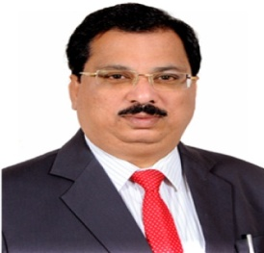
Faculty Details
PRINCIPAL

• Name :- Dr. Arun Vishwanath Parwate
• Date of Birth :- 22/10/1964
• Educational Qualifications :- B. E. (Civil Engg.), M.E. (Env. Engg.), Ph. D.
Teaching | Research | Industrial | Others
25 | 06 | 01 | =

• Work Experience (in Yrs.)

• Area of specialization :- Environmental Engineering
At U.G  level | At P.G  level
Environmental Engineering I & II,  Advanced Water Treatment,  Fluid Mechanics I & II  Hydrology & Irrigation Engineering,  Engineering Mechanics. | Environmental Science,  Environmental Sanitation,  Env. Policy & Law And Environmental Impact Assessment & Case Studies.
- Subject Taught

Master | Ph.D.
04 | 02
• Research Guidance

International Journal | National Journal | International Conference | National Conference
12 | 49 | 15 | 37

• No.of Papers Published
in

- No.of Projects Carried out :- 04
- No .of Patents :- 02
- Technology Transfer :- -
- Research Publications :- 113
- No. of Books published with details :- 01
Soil Mechanics & Foundation Engineering”, (For Final Year Diploma,
Civil Engineering Students of Vth Semester), Jai Prakash Nath
Publications in the year 2022.
- No. of Copy right :- -

Department: Civil Engineering
Faculty List
Sr . No. | Name | Designation
1 | Dr.P.B.Nagarnaik | Professor and HOD
2 | Dr. M. R. Vyawahare | Professor
3 | Prof. V. A. Fulari | Assistant Professor
4 | Prof. S.M.Jadhal | Assistant Professor
5 | Prof. P. R.Wankhede | Assistant Professor
6 | Prof. A. R. Bijwe | Assistant Professor
7 | Prof. P. R. Patil | Assistant Professor
8 | Prof. A. I. Malviya | Assistant Professor
9 | Prof. P. G. Bherene | Assistant Professor
10 | Prof. P. P. Wankhade | Assistant Professor
11 | Prof. S. A. Belsare | Assistant Professor
12 | Prof. V.S.Sarode | Assistant Professor
13 | Prof. M.M.Vyawahare | Assistant Professor
14 | Prof.D.V.More | Assistant Professor
15 | Prof. K.Q.Khan | Assistant Professor
16 | Prof.A. A. Shivankar | Assistant Professor
17 | Prof. Kasturi S.Ghormade | Assistant Professor
18 | Ms.Pooja R.Sangole | Lecture
19 | Mr. Nilesh S. Biswal | Lecture
20 | Mr.Prajawal .S.Guhe | Lecture
21 | Ms.Sonali.P.Pawar | Lecture
22 | Mr. Siddhant M. Parte | Lecture
23 | Mr. Shubham S. Shelokar | Lecture

Faculty Details
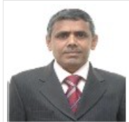
Civil Engineering

- Name :- Dr. Prashant Bharat Nagarnaik
- Date of Birth :- 11/04/1960
- Educational Qualifications :- Ph.D, M.Tech (Environmental Engineering ) B. E. Civil

- Work Experience (in Yrs.)
Teaching | Research | Industrial | Others
41

- Area of specialization :- Environmental Engineering
- Subject Taught
At U.G  level | At P.G  level
Environmental Engg. I , Environmental Engg. II, AWT, EIA. | EIA

- Research Guidance
Master | Ph.D
40 | 15

- No.of Papers Published in
International  Journal | National  Journal | International  Conference | National  Conference
65 | 23 | 40 | 20

• No. of Projects Carried out :-09
• No .of Patents :- 05
• Technology Transfer :- NIL
• Research Publications : 65
• No. of Books published with details : --
• No. of Copy right :- ----

Faculty Details
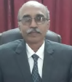
Civil Engineering

- Name :- Dr. M. R. Vyawahare
- Date of Birth :- 15/07/1965
- Educational Qualifications :- Ph.D. (Civil Engineering)

- Work Experience (in Yrs.)
Teaching | Research | Industrial | Others
34

- Area of specialization :- Structural Engineering and Advanced Concretes
At U.G  level | At P.G  level
Engineering Mechanics, Strength  of Materials, Theory of  Structures, Advance design of  RCC structures | Structural Dynamics, Design  of Prestressed structures
- Subject Taught

- Research Guidance

Master | Ph.D
15 | NIL

- No.of Papers Published in
International  Journal | National  Journal | International  Conference | National  Conference
22 | 1 | 2 | 1

• No. of Projects Carried out :-09
• No .of Patents :- 05
• Technology Transfer :- NIL
• Research Publications : 65
• No. of Books published with details : --
• No. of Copy right :- ----
\

Faculty Details
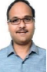
Civil Engineering

- Name :- Prof. Vaibhav Arvind Fulari
- Date of Birth :- 09/07/1984
- Educational Qualifications :- M TECH

- Work Experience (in Yrs.)
Teaching | Research | Industrial | Others
13

- Area of specialization :- Structural Engineering
- Subject Taught
At U.G  level | At P.G  level
SOM, EM, BBC, ADSS, DSS

- Research Guidance
Master | Ph.D
01 | NIL

- No.of Papers Published in
International  Journal | National  Journal | International  Conference | National  Conference
04

• No. of Projects Carried out :- 10
• No .of Patents :- 01
• Technology Transfer :- NIL
• Research Publications : 04
• No. of Books published with details : -- NIL
• No. of Copy right :- NIL

Faculty Details
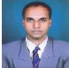
Civil Engineering

- Name :- Prof. Prasanna R. Wankhede
- Date of Birth :- 31/05/1986
- Educational Qualifications :- M. TECH. in Structural Engineering

- Work Experience (in Yrs.)
Teaching | Research | Industrial | Others
13

- Area of specialization :- Structural Engineering
- Subject Taught
At U.G  level | At P.G  level
SOM, ADRCC, NMCP, SURY | EIA

- Research Guidance
Master | Ph.D
NIL | NIL

- No.of Papers Published in
International  Journal | National  Journal | International  Conference | National  Conference
4 |  | 1 | 1

• No. of Projects Carried out :-10
• No .of Patents :- NIL
• Technology Transfer :- NIL
• Research Publications : 6
• No. of Books published with details : NIL
• No. of Copy right : - - NIL

Faculty Details
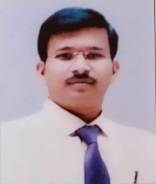
Civil Engineering

- Name :- Prof. Ashish Ramesh Bijwe
- Date of Birth :- 29/09/1988
- Educational Qualifications :- B.E. (Civil Engg), ME (Transportation Engg. & Management)

- Work Experience (in Yrs.)
Teaching | Research | Industrial | Others
10

- Area of specialization :- Transportation Engg. & Management
- Subject Taught
At U.G  level | At P.G  level
TRE-I, TRE-II, HCM, CEM, PD | TE&FS, DCP, TS

- Research Guidance
Master | Ph.D
10 | NIL

- No.of Papers Published in
International  Journal | National  Journal | International  Conference | National  Conference
25

• No. of Projects Carried out :-09
• No .of Patents :- NIL
• Technology Transfer :- NIL
• Research Publications : 25
• No. of Books published with details : -- NIL
• No. of Copy right :- -NIL

Faculty Details
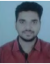
Civil Engineering

- Name :- Prof. Prathmesh Rajendra Patil
- Date of Birth :- 22/02/1993
- Educational Qualifications :- M. TECH. in Environmental Engineering

- Work Experience (in Yrs.)
Teaching | Research | Industrial | Others
11 |  | 1.5

- Area of specialization :- Environmental Engineering
- Subject Taught
At U.G  level | At P.G  level
EE-I, EE-II, AWT, FM-I

- Research Guidance
Master | Ph.D
NIL | NIL

- No.of Papers Published in
International  Journal | National  Journal | International  Conference | National  Conference
2 | 1 | 1 | 3

• No. of Projects Carried out :-07
• No .of Patents :- 01
• Technology Transfer :- NIL
• Research Publications : 7
• No. of Books published with details : -- NIL
• No. of Copy right :- - NIL

Faculty Details
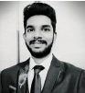
Civil Engineering

- Name :- Prof. Ankit Ishwardas Malviya
- Date of Birth :- 29/12/199
- Educational Qualifications :- B.E. (Civil), M.Tech. (Env. Engg.)

- Work Experience (in Yrs.)
Teaching | Research | Industrial | Others
5 |  | 2

- Area of specialization :- Structural Engineering and Advanced Concretes
- Subject Taught
At U.G  level | At P.G  level
CE & EC, BCM, FM-I, FM-II

- Research Guidance
Master | Ph.D
NIL | NIL

- No.of Papers Published in
International  Journal | National  Journal | International  Conference | National  Conference
3 |  | 2 | 2

• No. of Projects Carried out :-07
• No .of Patents :- NIL
• Technology Transfer :- NIL
• Research Publications : 7
• No. of Books published with details : -- NIL
• No. of Copy right :- NIL

Faculty Details
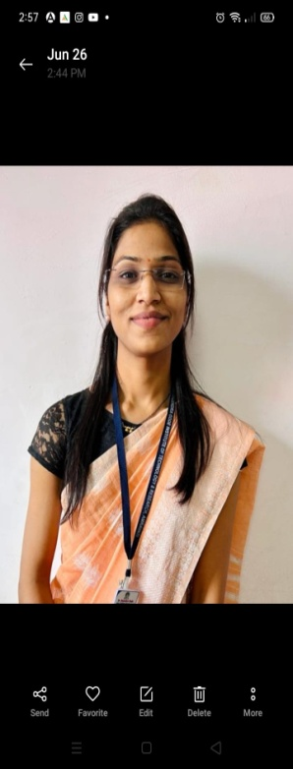
Civil Engineering

- Name :- Prof. Sneha Madanrao Jadhal
- Date of Birth :- 11/09/1991
- Educational Qualifications :- M.Tech (Geotech.), B.E.

- Work Experience (in Yrs.)
Teaching | Research | Industrial | Others
6

- Area of specialization :- Geotechnical Engineering
- Subject Taught
At U.G  level | At P.G  level
TRE, GT-I, GT-II, SURY, BCM

- Research Guidance
Master | Ph.D
3 | NIL

- No.of Papers Published in
International  Journal | National  Journal | International  Conference | National  Conference
3

• No. of Projects Carried out :- 05
• No .of Patents :- NIL
• Technology Transfer :- NIL
• Research Publications : 3
• No. of Books published with details : NIL
• No. of Copy right :- 02

Faculty Details
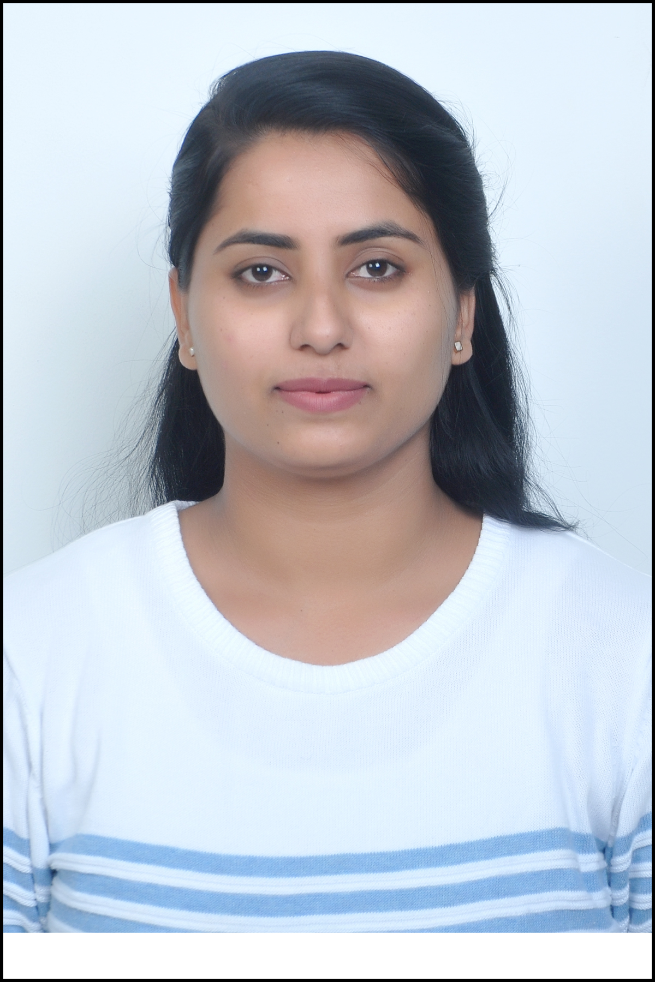
Civil Engineering

- Name :- Prof. Priyanka Pramodrao Wankhade
- Date of Birth :- 21/07/1996
- Educational Qualifications :- M. Tech.(Geotechnical Engg)

- Work Experience (in Yrs.)
Teaching | Research | Industrial | Others
4

- Area of specialization :- Geotechnical Engineering
- Subject Taught
At U.G  level | At P.G  level
CPM, SURY, TRE

- Research Guidance
Master | Ph.D
NIL | NIL

- No.of Papers Published in
International  Journal | National  Journal | International  Conference | National  Conference
 | 1 | 1

• No. of Projects Carried out :-05
• No .of Patents :- NIL
• Technology Transfer :- NIL
• Research Publications : 02
• No. of Books published with details : -NIL
• No. of Copy right :- NIL

Faculty Details
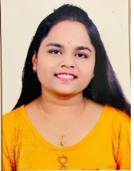
Civil Engineering

- Name :- Prof. Kasturi S.Ghormade
- Date of Birth :- 19-02-1999
- Educational Qualifications :- M.Tech.(Structural Engineering) B. E. Civil

- Work Experience (in Yrs.)
Teaching | Research | Industrial | Others
2

- Area of specialization :- Structural Engineering
- Subject Taught
At U.G  level | At P.G  level
CE&EC, BCM, SA-I

- Research Guidance
Master | Ph.D
NIL | NIL

- No.of Papers Published in
International  Journal | National  Journal | International  Conference | National  Conference
2

• No. of Projects Carried out :-02
• No .of Patents :- NIL
• Technology Transfer :- NIL
• Research Publications : 02
• No. of Books published with details : -NIL
• No. of Copy right :- NIL

Faculty Details
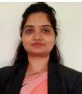
Civil Engineering

- Name :- Prof. Sharayu Ashokrao Belsare
- Date of Birth :- 04/01/1995
- Educational Qualifications :- M.Tech(Geotech.), B.E.

- Work Experience (in Yrs.)
Teaching | Research | Industrial | Others
04

- Area of specialization :- Geotechnical Engineering
- Subject Taught
At U.G  level | At P.G  level
GT-I, GT-II, HYWRA, EE-I

- Research Guidance
Master | Ph.D
NIL | NIL

- No.of Papers Published in
International  Journal | National  Journal | International  Conference | National  Conference
02 |  | 01

• No. of Projects Carried out :-05
• No .of Patents :- NIL
• Technology Transfer :- NIL
• Research Publications : 03
• No. of Books published with details : -NIL
• No. of Copy right :- NIL

Faculty Details
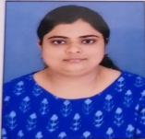
Civil Engineering

- Name :- Prof. Payal Govind Bherane
- Date of Birth :- 01/01/1993
- Educational Qualifications : - M.Tech (Construction Mngt. ) B. E. Civil

- Work Experience (in Yrs.)
Teaching | Research | Industrial | Others
2

- Area of specialization :- Construction Mngt.
- Subject Taught
At U.G  level | At P.G  level
CPM, TRE, BCM

- Research Guidance
Master | Ph.D
NIL | NIL

- No.of Papers Published in
International  Journal | National  Journal | International  Conference | National  Conference
2

• No. of Projects Carried out :-02
• No .of Patents :- NIL
• Technology Transfer :- NIL
• Research Publications : 02
• No. of Books published with details : -NIL
• No. of Copy right :- NIL

Faculty Details
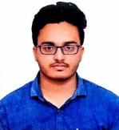
Civil Engineering

- Name :- Prof. Kashif khan Qaiyum Khan
- Date of Birth :- 15/05/1997
- Educational Qualifications :- M.Tech (Structural Engineering)

- Work Experience (in Yrs.)
Teaching | Research | Industrial | Others
2

- Area of specialization :- Structural Engineering
- Subject Taught
At U.G  level | At P.G  level
CTRCC, SA-II, SA-I

- Research Guidance
Master | Ph.D
NIL | NIL

- No.of Papers Published in
International  Journal | National  Journal | International  Conference | National  Conference
2

• No. of Projects Carried out :-02
• No .of Patents :- NIL
• Technology Transfer :- NIL
• Research Publications : 02
• No. of Books published with details : -NIL
• No. of Copy right :- NIL

Faculty Details
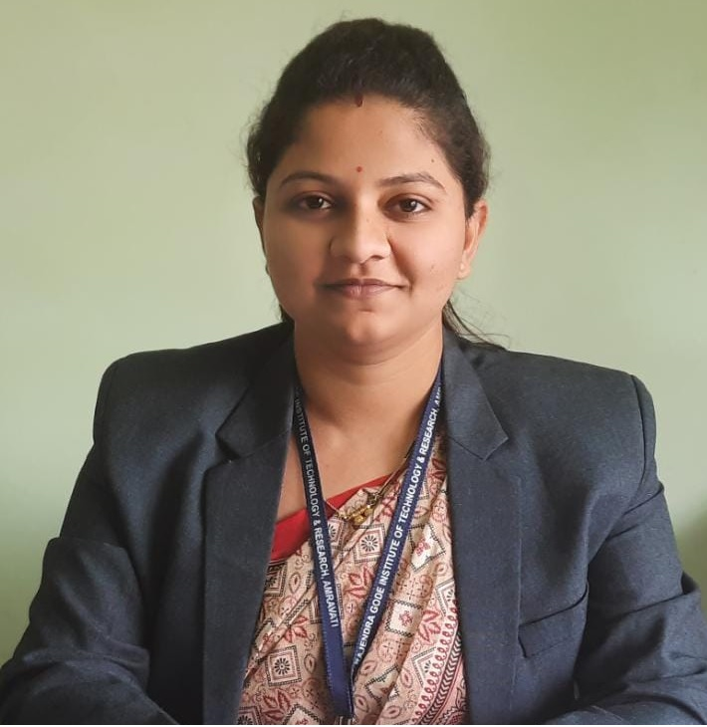
Dept. Name: Civil Engineering (Diploma)

• Name : - Pooja Rajendra Sangole
• Date of Birth : - 03/06/1995
• Educational Qualifications : - B.E (Civil), M.E Transportation Engg. & Management
Teaching | Research | Industrial | Others
6.5 |  | -

• Work Experience (in Yrs.)

• Area of specialization : - Transportation Engg. & Management
At U.G  level | At P.G  level | At Diploma  level
Engg. Mechanics |  | Engg. Mechanics  Building Planning & drawing  Solid Waste Management  Railway Engg.
- Subject Taught

Master | Ph.D
-- | --
• Research Guidance

International Journal | National Journal | International Conference | National Conference
01 | -- | -- | --

• No.of Papers Published in

- No. of Projects Carried out :- 02
- No .of Patents :- NIL
- Technology Transfer :- NIL
- Research Publications :- 01
- No. of Books published with details :- NIL
- No. of Copy right :- NIL

Faculty Details
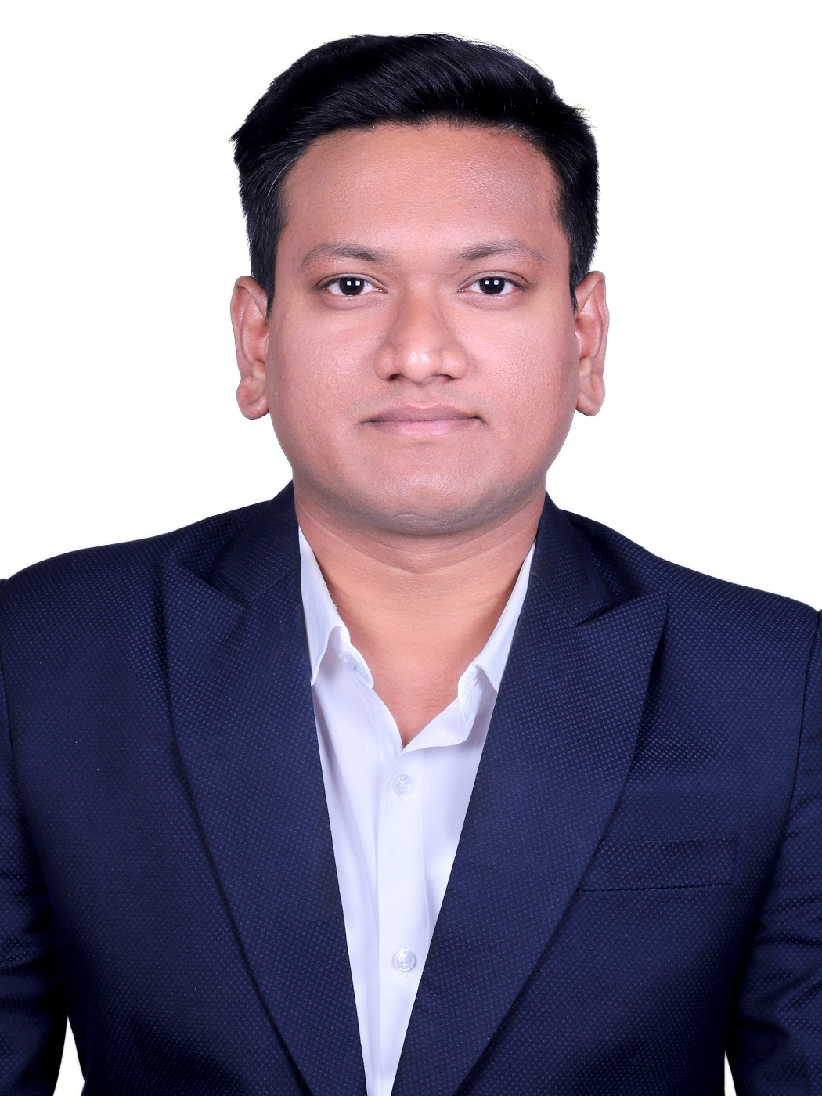
Dept. Name: Civil Engineering (Diploma)

• Name : - Nilesh Sushant Biswal
• Date of Birth :- 26/07/1996
• Educational Qualifications :- B.E (Civil), M.Tech (Structural Engg.)*
Teaching | Research | Industrial | Others
1.5 yrs | - | - | -

• Work Experience (in Yrs.)

• Area of specialization :- Structural Engineering
At U.G  level | At P.G  level | At Diploma  level
Design of Steel & RCC
Estimating & Costing
Geotechnical Engineering
Surveying
Contracts & Accounts
- Subject Taught

Master | Ph.D
-- | --
• Research Guidance

International Journal | National Journal | International Conference | National Conference
03 | -- | -- | --
• No.of Papers Published in

- No.of Projects Carried out :- 02
- No .of Patents :- NIL
- Technology Transfer :- NIL
- Research Publications :- 03
- No. of Books published with details :- NIL
- No. of Copy right :- NIL

Faculty Details
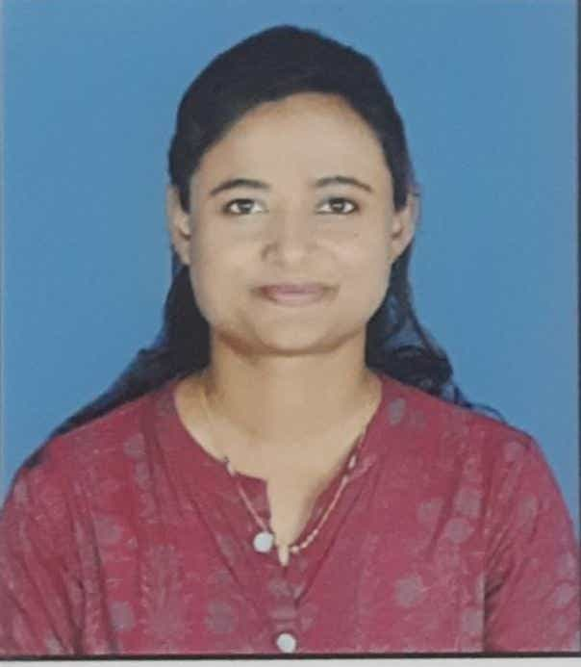
Dept. Name: Civil Engineering (Diploma)

• Name :- Sonali Pramod Pawar
• Date of Birth :- 21/03/1990
• Educational Qualifications :- B.E (Civil), M.E Transportation Engg. & Management
Teaching | Research | Industrial | Others
6.7 | - | - | -

• Work Experience (in Yrs.)

• Area of specialization : - Transportation Engg. & Management
At U.G  level | At P.G  level | At Diploma  level
Transporation-1  Transporation-2  Project Management  Estimating & costing |  | Highway  Building Construction  Theory of Structure  Engg. Mechanics  Maintenance & repair  .
- Subject Taught

Master | Ph.D
-- | --
• Research Guidance

International Journal | National Journal | International Conference | National Conference
02 | -- | -- | --
• No.of Papers Published in

- No. of Projects Carried out :- 02
- No .of Patents :- NIL
- Technology Transfer :- NIL
- Research Publications :- 02
- No. of Books published with details :- NIL
- No. of Copy right :- NIL

Faculty Details
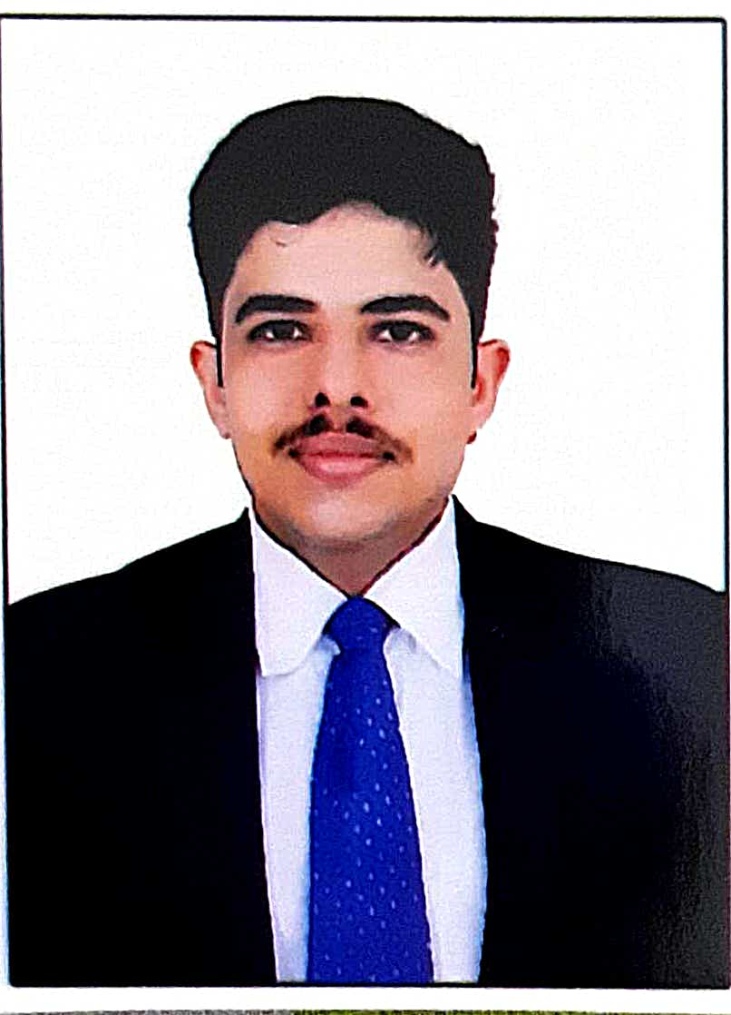
Dept. Name: Civil Engineering (Diploma)

• Name :- Prajwal Sunil Guhe
• Date of Birth :- 27/04/2000
• Educational Qualifications :- B.E (Civil), M.E (Transportation Engg. & Management)*
Teaching | Research | Industrial | Others
0.8 yrs | - | - | -

• Work Experience (in Yrs.)

• Area of specialization : - Transportation Engg. & Management
At U.G  level | At P.G  level | At Diploma  level
Water Resource Engg.
Rural Development
Hydraulics
Emerging Trends.
- Subject Taught

Master | Ph.D
-- | --
• Research Guidance

International Journal | National Journal | International Conference | National Conference
-- | -- | -- | --
• No.of Papers Published in

- No. of Projects Carried out :- 02
- No .of Patents :- NIL
- Technology Transfer :- NIL
- Research Publications :- NIL
- No. of Books published with details :- NIL
- No. of Copy right :- NIL

Faculty Details
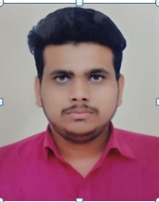
Dept. Name: Civil Engineering (Diploma)

• Name :- Pranay Ramdas Adhau
• Date of Birth :- 14/09/1995
• Educational Qualifications :- B.E (Civil)
Teaching | Research | Industrial | Others
2 yrs | - | - | -

• Work Experience (in Yrs.)

• Area of specialization : -
At U.G  level | At P.G  level | At Diploma  level
Management
Theory of Subjects
Geotechnical Engineering
EDP
- Subject Taught

Master | Ph.D
-- | --
• Research Guidance

International Journal | National Journal | International Conference | National Conference
-- | -- | -- | --
• No.of Papers Published in

- No. of Projects Carried out :- 02
- No .of Patents :- NIL
- Technology Transfer :- NIL
- Research Publications :- NIL
- No. of Books published with details :- NIL
- No. of Copy right :- NIL

Faculty Details
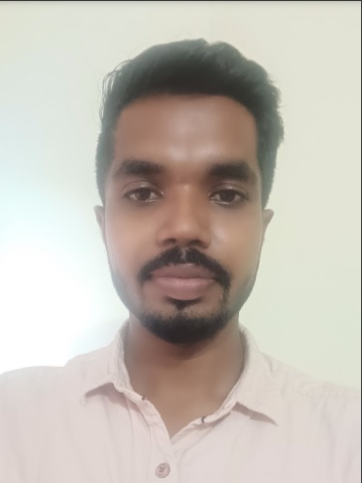
Dept. Name: Civil Engineering (Diploma)

• Name :- Shubham Sudhakar Shelokar
• Date of Birth :- 27/04/2000
• Educational Qualifications :- B.E (Civil)
Teaching | Research | Industrial | Others
1 yrs | - | - | -

• Work Experience (in Yrs.)

• Area of specialization : -
At U.G  level | At P.G  level | At Diploma  level
Concrete Technology
Railway Engg.
Workshop
Building Construction
- Subject Taught

Master | Ph.D
-- | --
• Research Guidance

International Journal | National Journal | International Conference | National Conference
-- | -- | -- | --
• No.of Papers Published in

- No. of Projects Carried out :- 02
- No .of Patents :- NIL
- Technology Transfer :- NIL
- Research Publications :- NIL
- No. of Books published with details :- NIL
- No. of Copy right :- NIL

Faculty Details
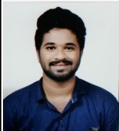
Dept. Name: Civil Engineering (Diploma)

• Name :- Sidhant. Murlidhar. Patre
• Date of Birth :- 07/11/1995
• Educational Qualifications :- B.E (Civil)
Teaching | Research | Industrial | Others
1 yrs | - | - | -

• Work Experience (in Yrs.)

• Area of specialization : -
At U.G  level | At P.G  level | At Diploma  level
Advanced Surveying
Construction Management
Public Health Engg.
- Subject Taught

Master | Ph.D
-- | --
• Research Guidance

International Journal | National Journal | International Conference | National Conference
-- | -- | -- | --
• No.of Papers Published in

- No. of Projects Carried out :- 01
- No .of Patents :- NIL
- Technology Transfer :- NIL
- Research Publications :- NIL
- No. of Books published with details :- NIL
- No. of Copy right :- NIL

Department of Mechanical Engineering Faculty List
Sr.No. | Name | Qualification | Designation | Teaching Level
01 | Dr. S. C. Jirapure | Ph.D, M.E., M.B.A., B.E | Head & Assoc.  Professor | PG
02 | Dr. M. R. Dharme | BE(Prod.) ME(CAD/CAM) PhD(Mech) | Assoc.  Professor | PG
03 | Prof. A. A. Shahade | BE,ME(CAD CAM) | Assistant  Professor | PG
04 | Prof. S. A. Pande | BE(Mechanical) M-Tech(Thermal  Engineering) | Assistant  Professor | UG
05 | Dr. S. S. Dandge | BE(Prod.) ME(Production) PhD(Mech) | Assoc.  Professor | PG
06 | Prof. Y. B. Bhagat | BE (Prod. Engg.)M.E.(CAD/CAM) | Assistant  Professor | UG
07 | Prof. M. R. Dhawade | BE(Mechanical) ME(Production) | Assistant  Professor | UG
08 | Prof. K. K. Padghan | BE(Mechanical) ME(CAD/CAM) | Assistant  Professor | UG
09 | Prof. S. S. Galgat | BE(Mechanical) ME(Automotive)  PhD(Pursuing) | Assistant  Professor | UG
10 | Prof. A. G. Bhatkar | BE(Mechanical) ME(CAD/CAM) | Assistant  Professor | UG
11 | Prof. N. D. Jeughale | BE(Mechanical) M-Tech(Thermal Engineering) | Assistant  Professor | UG
12 | Prof. Pratik Yadav | BE(Mechanical) ME(Production) | Assistant  Professor | UG
13 | Prof. Amrish Anantwar | BE(Mechanical) M.Tech.(Heat Power) | Assistant  Professor | UG
14 | Prof. Aniruddha Narkhede | BE(Mechanical) ME(CAD/CAM) | Assistant  Professor | UG
15 | Mr. R. R. Gupta | BE(Mechanical) M.E(Thermal) | Lecturer | Diploma
16 | Mr. K. G. Guhe | BE(Mechanical) M.E(Thermal) | Lecturer | Diploma
17 | Ms. A. R. Gole | BE(Mechanical) | Lecturer | Diploma
18 | Mr. N. V. Kherde | BE(Mechanical) | Lecturer | Diploma
19 | Mr. A. A. Gulalkari | BE(Mechanical) | Lecturer | Diploma
20 | Mr.T. O. Deshmukh | BE(Mechanical) | Lecturer | Diploma
21 | Ms. V. A. Panchgade | BE(Mechanical) | Lecturer | Diploma
22 | Mr. Nilesh Kandalkar | BE(Mechanical) | Lecturer | Diploma

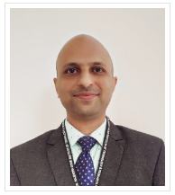

Name :-Dr. S. C. Jirapure
Date of Birth :- 01/08/1980
Educational Qualifications :- BE (Mechanical Engineering), ME (CAD CAM), PhD (Mechanical
Engineering)

Work Experience (in Yrs.)
Teaching | Research | Industrial | Others
20 | -- | 01 | --

Area of specialization : - CAD CAM Subject Taught
At UG Level | At PG Level
Manufacturing Process, Material Science, Engineering Metallurgy, Non Conventional Energy Source. | Nil

Research Guidance
Master | Ph. D
01 | Nil

No. of Papers Published in
International  Journal | National  Journal | International  Conference | National  Conference
45 | 24 | 20 | 24

- No. of Projects Carried out | :- | 20
- No. of Patents | :- | 04
- Technology Transfer | :- | Nil
- Research Publications | :- | Nil
- No. of Books published with details | :- | 02
- No. of Copy Rights :- 02

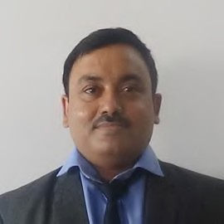
Name :-Dr. M. R. Dharme
Date of Birth :- 02/06/1980
Educational Qualifications :- BE (Mechanical Engineering), ME (CAD CAM), PhD (Mechanical
Engineering)

Work Experience (in Yrs.)
Teaching | Research | Industrial | Others
17 | NIL | 02 | NIL

Area of specialization :- CAD CAM Subject Taught
At UG Level | At PG Level
Machine Design, Control System  Engineering, Robotics | Environment Pollution Control

Research Guidance
Master | Ph. D
10 | 01

No. of Papers Published in
International  Journal | National  Journal | International  Conference | National  Conference
15 | 00 | 03 | 00

- Projects Carried out | :- | 17 at UG level & 10 at PG level
- Patents | :- | 04
- Technology Transfer | :- | Nil
- Research Publications | :- | Nil
- No. of Books published with details | :- | Nil
- No. of Copy Rights :- 01

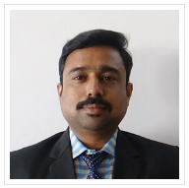
Name :-Prof. A. A. Shahade
Date of Birth :- 23/09/1980
Educational Qualifications :- BE (Mechanical Engineering), ME (CAD/CAM), PhD (App.)

Work Experience (in Yrs.)
Teaching | Research | Industrial | Others
16 | NIL | 02 | NIL

Area of specialization :- CAD/CAM
At UG Level | At PG Level
IMC, Control System  Engineering | Nil

Subject Taught

Research Guidance
Master | Ph. D
NIL | NIL

No. of Papers Published in
International  Journal | National  Journal | International  Conference | National  Conference
15 | 05 | 03 | 00

- Projects Carried out | :- | 12 at UG level
- Patents | :- | 02
- Technology Transfer | :- | Nil
- Research Publications | :- | Nil
- No. of Books published with details  - No. of Copy Rights | :- | Nil

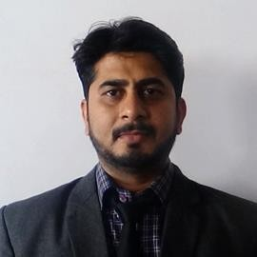
Name :-Prof. S. A. Pande
Date of Birth :-03/06/1983
Educational Qualifications :- BE (Mechanical Engineering), M.Tech (Thermal Engineering), Work Experience (in Yrs.)
Teaching | Research | Industrial | Others
14 | NIL | 01 | NIL

Area of specialization :-Thermal Engineering Subject Taught
At UG Level | At PG Level
Engineering Thermodynamics, Heat Transfer, Energy Conversion, Machine  Design, Engineering Drawing. | Advance Heat Transfer. Advance  I.C. Engine

Research Guidance
Master | Ph. D
00 | 00

No. of Papers Published in
International  Journal | National  Journal | International  Conference | National  Conference
08 | 02 | 05 | 02

- Projects Carried out | :- | 15 at UG level
- Patents | :- | 02
- Technology Transfer | :- | Nil
- Research Publications | :- | 12
- No. of Books published with details | :- | 00

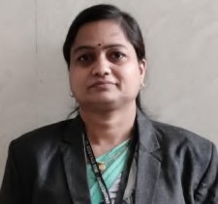
Name :-Prof. Y. B.Bhagat
Date of Birth :- 29/01/1976
Educational Qualifications :- BE (Production Engineering), ME (CAD CAM) Work Experience (in Yrs.)
Teaching | Research | Industrial | Others
14 | NIL | NIL | NIL

Area of specialization : - Production, Mechatronics
At UG Level | At PG Level
Automation Engineering, Production Technology, Fluid Power, Operation  Research and Techniques | NIL

Subject Taught

Research Guidance
Master | Ph. D
NIL | NIL

No. of Papers Published in
International  Journal | National  Journal | International  Conference | National  Conference
03 | 01 | 01 | 00

- Projects Carried out | :- | 12 at UG level
- Patents | :- | Nil
- Technology Transfer | :- | Nil
- Research Publications | :- | Nil
- No. of Books published with details | :- | Nil
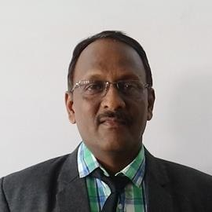

Name :-Prof. M. R. Dhawade
Date of Birth :- 14/11/1971
Educational Qualifications :- BE (Mechanical Engineering), ME (PTM), Work Experience (in Yrs.)
Teaching | Research | Industrial | Others
11 | NIL | 09 | NIL

Area of specialization : - Manufacturing Subject Taught
At UG Level | At PG Level
Manufacturing Process, Automobile  Engineering | NIL

Research Guidance
Master | Ph. D
NIL | NIL

No. of Papers Published in
International  Journal | National  Journal | International  Conference | National  Conference
10 | 00 | 00 | 00

- Projects Carried out | :- | 10 at UG level
- Patents | :- | Nil
- Technology Transfer | :- | Nil
- Research Publications | :- | Nil
- No. of Books published with details | :- | Nil

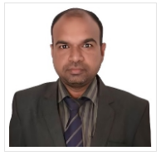
Name :-Prof. K. K. Padghan
Date of Birth : - 07/07/1984
Educational Qualifications BE (Mechanical Engineering), ME (CAD/CAM),
Teaching | Research | Industrial | Others
13 | NIL | NIL | NIL

Work Experience (in Yrs.)

Area of specialization :-Thermal Engineering Subject Taught
At UG Level | At PG Level
Fluid Power, Theory of Machine. | NIL

Research Guidance
Master | Ph. D
NIL | NIL

No. of Papers Published in
International  Journal | National  Journal | International  Conference | National  Conference
10 | 04 | 00 | 04

- Projects Carried out | :- | 12 at UG level
- Patents | :- | Nil
- Technology Transfer | :- | Nil
- Research Publications | :- | Nil
- No. of Books published with details | :- | Nil

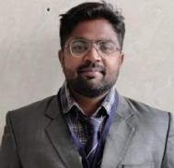
Name : - Prof. S. S. Galgat
Date of Birth : - 11/07/1990
Educational Qualifications : - BE (Mechanical Engineering), ME (Automotive
Engineering), PhD Pursuing

Work Experience (in Yrs.)
Teaching | Research | Industrial | Others
8 | NIL | NIL | NIL

Area of specialization :-Automotive Engineering, Thermal Engineering
At UG Level | At PG Level
Engineering Thermodynamics, Heat  Transfer, Energy Conversion. | NIL

Subject Taught

Research Guidance
Master | Ph. D
NIL | NIL

No. of Papers Published in
International  Journal | National  Journal | International  Conference | National  Conference
06 | 01 | 03 | 01

- Projects Carried out | :- | 08 at UG level
- Patents | :- | 01
- Technology Transfer | :- | Nil
- Research Publications | :- | 02
- No. of Books published with details | :- | Nil

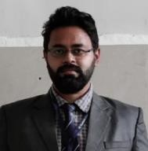
Name : Prof. A. G. Bhatkar
Date of Birth : - 04/06/1987
Educational Qualifications :-BE (Mechanical Engineering), ME (CAD CAM), Work Experience (in Yrs.)
Teaching | Research | Industrial | Others
11 | NIL | NIL | NIL

Area of specialization :-CAD CAM Subject Taught
At UG Level | At PG Level
Mechanics of Material, Measurement  System, Machine Design | NIL

Research Guidance
Master | Ph. D
NIL | NIL

No. of Papers Published in
International  Journal | National  Journal | International  Conference | National  Conference
01 | 07 | 00 | 00

- Projects Carried out : 09 at UG level
- Patents : 01
- Technology Transfer : Nil
- Research Publications :-Nil No. of Books published with details :-Nil

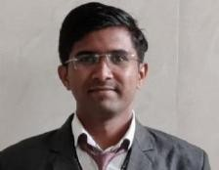
Faculty Details
Mechanical Engineering Department

Name :-Prof. N. D. Jeughale
Date of Birth :- 10/09/1993
Educational Qualifications :- BE (Mechanical Engineering) ME (Thermal Engineering)
Teaching | Research | Industrial | Others
03 | NIL | 01 | NIL

Work Experience (in Yrs.)

Area of specialization : - Thermal Engineering Subject Taught
At UG Level | At PG Level
Automobile Engineering, Renewable Energy Technologies, Hydraulics & Pneumatics, Strength of Material, Machine Design, Engineering Metallurgy, Manufacturing  Process | NIL

Research Guidance
Master | Ph. D
NIL | NIL

No. of Papers Published in
International  Journal | National  Journal | International  Conference | National  Conference
01 | 01 | 00 | 02

- Projects Carried out | :- | 05
- Patents | :- | 01
- Technology Transfer | :- | Nil
- Research Publications | :- | Nil
- No. of Books published with details | :- | Nil

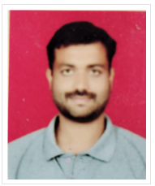
Faculty Details
Mechanical Engineering Department

Name :-Prof. Pratik B. Yadav
Date of Birth :- 14/09/1991
Educational Qualifications :- BE (Mechanical Engineering) ME (CAD/CAM)
Teaching | Research | Industrial | Others
06 | NIL | 01 | NIL

Work Experience (in Yrs.)

Area of specialization : - CAD/CAM
At UG Level | At PG Level
Automobile Engineering, Machine Design. | NIL

Subject Taught

Research Guidance
Master | Ph. D
NIL | NIL

No. of Papers Published in
International  Journal | National  Journal | International  Conference | National  Conference
01 | 01 | 00 | 02

- Projects Carried out | :- | 05
- Patents | :- | Nil
- Technology Transfer | :- | Nil
- Research Publications | :- | Nil
- No. of Books published with details | :- | Nil

Faculty Details
Mechanical Engineering Department
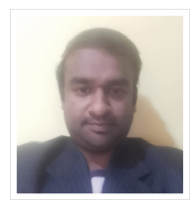
Name :-Prof. A. L. Anantwar
Date of Birth :- 15/07/1992
Educational Qualifications :- BE (Mechanical Engineering) ME (Thermal Engineering)
Teaching | Research | Industrial | Others
09 | NIL | 01 | NIL

Work Experience (in Yrs.)

Area of specialization :- Thermal Engineering
At UG Level | At PG Level
Refrigeration and Air Conditioning, Heat Transfer. | NIL

Subject Taught

Research Guidance
Master | Ph. D
NIL | NIL

No. of Papers Published in
International  Journal | National  Journal | International  Conference | National  Conference
05 | 02 | 00 | 02

- Projects Carried out | :- | 08
- Patents | :- | Nil
- Technology Transfer | :- | Nil
- Research Publications | :- | Nil
- No. of Books published with details | :- | Nil

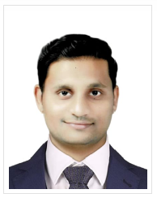
Faculty Details
Mechanical Engineering Department

Name :-Prof. A. P. Narkhedkar
Date of Birth :- 21/12/1988
Educational Qualifications :- BE (Mechanical Engineering) ME (CAD/CAM)
Teaching | Research | Industrial | Others
07 | NIL | 01 | NIL

Work Experience (in Yrs.)

Area of specialization :- Thermal Engineering
At UG Level | At PG Level
Kinematics of Machine, Fluid Mechanics. | NIL

Subject Taught

Research Guidance
Master | Ph. D
NIL | NIL

No. of Papers Published in
International  Journal | National  Journal | International  Conference | National  Conference
05 | 02 | 00 | 00

- Projects Carried out | :- | 06
- Patents | :- | 01
- Technology Transfer | :- | Nil
- Research Publications | :- | Nil
- No. of Books published with details | :- | Nil

Faculty Details
Dept. Name: Mechanical Engineering (Diploma)
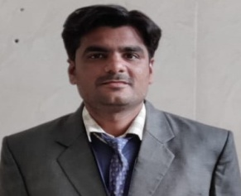
• Name :- Robin Ramesh Gupta
• Date of Birth :- 28/05/1985
• Educational Qualifications :- B.E (Mechanical), M.E Thermal Engg.
Teaching | Research | Industrial | Others
13 |  | 02

• Work Experience (in Yrs.)

• Area of specialization :- Thermal Engg.
At U.G  level | At P.G  level | At Diploma  level
 |  | Automobile Engineering, Manufacturing Processes, Thermal Engineering, Power Plant Engineering, Engineering Drawing
- Subject Taught

Master | Ph.D
-- | --
• Research Guidance

International Journal | National Journal | International Conference | National Conference
-- | -- | -- | 02
• No. of Papers Published in

- No. of Projects Carried out :- 02
- No .of Patents :- NIL
- Technology Transfer :- NIL
- Research Publications :- NIL
- No. of Books published with details :- NIL
- No. of Copy right :- NIL

Faculty Details
Dept. Name: Mechanical Engineering (Diploma)
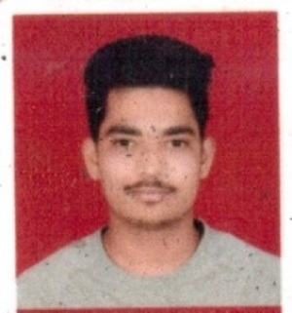
• Name :- Tejas Onkarrao Deshmukh
• Date of Birth :- 21/08/1996
• Educational Qualifications :- B.E (Mechanical)
Teaching | Research | Industrial | Others
2 Yrs |  | 1 year

• Work Experience (in Yrs.)

• Area of specialization :- Mechanical Engg.
At U.G  level | At P.G  level | At Diploma  level
 |  | Mechanical Engg. Measurment,Industrial Hydraulics and Pnumatics,Emerging Trends In Mechanical Engg.
- Subject Taught

Master | Ph.D
-- | --
• Research Guidance

International Journal | National Journal | International Conference | National Conference
-- | -- | -- | --

• No.of Papers Published in

- No.of Projects Carried out :- 02
- No .of Patents :- NIL
- Technology Transfer :- NIL
- Research Publications :- NIL
- No. of Books published with details :- NIL
- No. of Copy right :- NIL

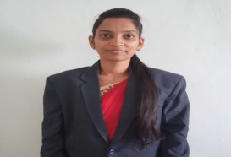
Faculty Details
Dept. Name: Mechanical Engineering (Diploma)
• Name :- Achal Ravindra Gole
• Date of Birth :- 22/08/1997
• Educational Qualifications :- B.E (Mechanical), M.E CAD-CAM
Teaching | Research | Industrial | Others
2 Yr |  | 1.5 Yrs

• Work Experience (in Yrs.)

• Area of specialization :- CAD-CAM
At U.G  level | At P.G  level | At Diploma  level
 |  | Manufacturing Process,Automobile Engg.,Manufacturing Technology
- Subject Taught

Master | Ph.D
-- | --
• Research Guidance

International Journal | National Journal | International Conference | National Conference
01 | -- | -- | --
• No.of Papers Published in

- No.of Projects Carried out :- 02
- No .of Patents :- NIL
- Technology Transfer :- NIL
- Research Publications :- NIL
- No. of Books published with details :- NIL
- No. of Copy right :- NIL

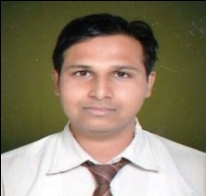
Faculty Details
Dept. Name: Mechanical Engineering (Diploma)
• Name :- Swapnil Sanjay Gurjar
• Date of Birth :- 05/06/1987
• Educational Qualifications :- B.E (Mechanical), M.E CAD-CAM (Pursuing)

Teaching | Research | Industrial | Others
1 Yr |  | 05 Yrs

• Work Experience (in Yrs.)

• Area of specialization :- CAD/CAM
At U.G  level | At P.G  level | At Diploma  level
 |  | Strength of Materials,Mechanical Working Drawing,IEQ&C.
- Subject Taught

Master | Ph.D
-- | --
• Research Guidance

International Journal | National Journal | International Conference | National Conference
-- | -- | -- | --

• No.of Papers Published in

- No.of Projects Carried out :- 02
- No .of Patents : NIL
- Technology Transfer :- NIL
- Research Publications :- NIL
- No. of Books published with details :- NIL
- No. of Copy right :- NIL

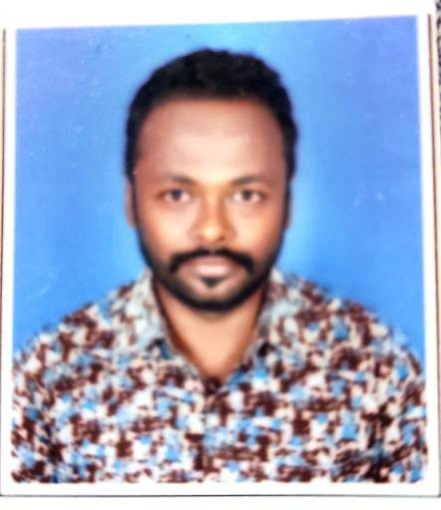
Faculty Details
Dept. Name: Mechanical Engineering (Diploma)

• Name :- Nikesh V. Kherde
• Date of Birth :- 10/02/1990
• Educational Qualifications :- B.E (Mechanical)
Teaching | Research | Industrial | Others
05 | - | - | -

• Work Experience (in Yrs.)

• Area of specialization :- Automobile Engg.
At U.G  level | At P.G  level | At Diploma  level
Engg. Drawing, Power Engineering, Fluid mechanics,
Automobile Engg.
- Subject Taught

Master | Ph.D
-- | --

• Research Guidance

International Journal | National Journal | International Conference | National Conference
-- | -- | --
• No.of Papers Published in

- No.of Projects Carried out :- 02
- No .of Patents :- NIL
- Technology Transfer :- NIL
- Research Publications :- NIL
- No. of Books published with details :- NIL
- No. of Copy right :- NIL

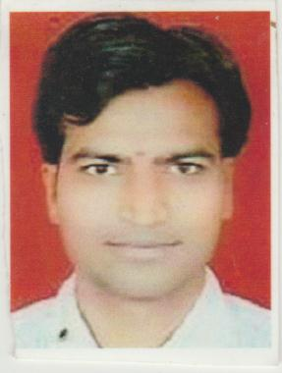
Faculty Details
Dept. Name: Mechanical Engineering (Diploma)

• Name :- Niranjan B. Kandalkar
• Date of Birth :- 28/02/1986
• Educational Qualifications :- B.E (Mechanical)
Teaching | Research | Industrial | Others
10 | - | -

• Work Experience (in Yrs.)

• Area of specialization :- Automobile Engg.
At U.G  level | At P.G  level | At Diploma  level
 |  | Engg. Drawing, Engg. Mechanics, Refrigeration & air Conditioning
- Subject Taught

Master | Ph.D
-- | --

• Research Guidance

International Journal | National Journal | International Conference | National Conference
-- | -- | --

• No.of Papers Published in

- No.of Projects Carried out :- 01
- No .of Patents :- NIL
- Technology Transfer :- NIL
- Research Publications :- NIL
- No. of Books published with details :- NIL
- No. of Copy right :- NIL

Faculty Details
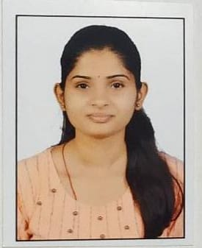
Dept. Name: Mechanical Engineering (Diploma)

• Name :- Vaishnavi C. Kapile
• Date of Birth :- 29/04/1998
• Educational Qualifications :- B.E (Mechanical), M.E. (Pursuing)
Teaching | Research | Industrial | Others

• Work Experience (in Yrs.)

• Area of specialization :- Thermal Engg.
At U.G  level | At P.G  level | At Diploma  level
Power Engg.,
Power Plant Engineering
- Subject Taught

Master | Ph.D
-- | --
• Research Guidance

International Journal | National Journal | International Conference | National Conference
-- | -- | --

• No.of Papers Published in

- No.of Projects Carried out :- NIL
- No .of Patents :- NIL
- Technology Transfer :- NIL
- Research Publications :- NIL
- No. of Books published with details :- NIL
- No. of Copy right :- NIL

Department Of Electronics and Telecommunication Engineering
Faculty Details
Sr.No. | Name | Qualification | Designation | Teaching Level
1 | Dr.A.O. Vyas | M.E,PHD | Asso. Professor&Head | UG,PG
2 | Dr. Ravindra M. Deshmukh | M.E,PHD | Professor | UG
3 | Prof. Kanchan M.Pimple | M.E | Assistant Professor | UG,PG
4 | Prof. Praveen P.Likhitkar | M.E | Assistant Professor | UG,PG
5 | Prof. Ravindra R. Solanke | M.E | Assistant Professor | UG,PG
6 | Prof. R.S.Shriwas | M.E | Assistant Professor | UG
7 | Prof. R.R.Sharma | M.E | Assistant Professor | UG
8 | Prof. R.A.Wakode | M.E | Assistant Professor | UG
9 | Prof. A.S.Chaudhari | M.E | Assistant Professor | UG
10 | Prof. M.N.Harne | M.E | Assistant Professor | UG
11 | Prof. D.B.Patil | M.E | Assistant Professor | UG
12 | Prof. Harshal D.Deshmukh | BE | Lecturer | DIPLOMA
13 | Prof. Saurabh R.Chaudhari | BE | Lecturer | DIPLOMA
14 | Prof. Dhananjay A.Deshpande | BE | Lecturer | DIPLOMA
15 | Prof. Akshay R.Khadse | BE | Lecturer | DIPLOMA
16 | Prof. Swapnil Sonar | BE | Lecturer | DIPLOMA

Faculty Details
Department of Electronics & Tele-Communication Engineering
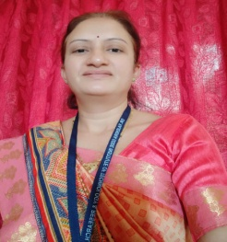
- Name :- Dr. Archana O. Vyas (HOD)
• Date of Birth :- 22/08/1980
• Educational Qualifications :- Ph.D. , M. Tech. (ESC), B.E.
Teaching | Research | Industrial | Others
15 | 4 | - | -

• Work Experience (in Yrs.)

• Area of specialization :- Computational intelligence, Network security
At U.G  level | At P.G  level
DSD, EDC, Comm. Network, Satellite comm., Fiber optic comm. , Analog and Digital comm., Wireless comm.. | Wireless communication, mobile computing, Advance optical comm., Cryptography and network security,
- Subject Taught

Master | Ph.D
12 | 02
• Research Guidance

International Journal | National Journal | International Conference | National Conference
32 | - | 04 | -

• No. of Papers Published in

- No. of Projects Carried out :- 22
- No .of Patents :- 02 (Published)
- Technology Transfer :- -
- Research Publications :- 32
- No. of Books published with details :- Nil
- No. of Copy right :- 05 (Registered)

Faculty Details
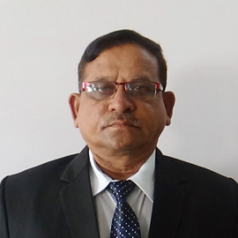
Electronics & Telecommunication Engineering

Name :- Dr.Ravindra M.Deshmukh
Date of Birth :- 17/11/1963
Educational Qualifications :- Ph.D., M.E(Electronics),PGDCS
Teaching | Research | Industrial | Others
37 | 13 | - | -
Work Experience (in Yrs.)

Area of specialization : - Wireless Communication, Microprocessor & Micro controller, Analog & Digital Communication
At UG Level | At PG Level
ADC,WCOM, SATCOMM | WCOM,OFC
Subject Taught

Master | Ph.D
16 | 01
Research Guidance

International Journal | National Journal | International Conference | National Conference
35 | 12 | 19 | 09
No. of Papers Published in

Projects Carried out :- 47
Patents :-04
Technology Transfer :-Nil
Research Publications :-04
No. of Books published with details :- 02
No. of Copy right :- 02

Faculty Details
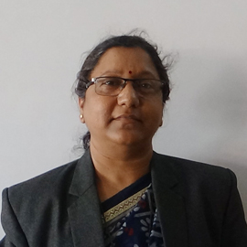
Electronics & Telecommunication Engineering

Name Prof.Kanchan Madhukar Pimple
Date of Birth 15/06/1972
Educational Qualifications:- BE,ME
Teaching | Research | Industrial | Others
17Yrs | - | - | -
Work Experience (in Yrs.)

Area of specialization :-Digital Electronics
At UG Level | At PG Level
EDC,DSP,BME | ADSP
Subject Taught

Master | Ph. D
4 | -
Research Guidance

International Journal | National Journal | International Conference | National Conference
13 | - | 6 | -
No. of Papers Published in

Projects Carried out :- 8
Patents :-1
Technology Transfer :- Nil
Research Publications :-19
No. of Books published with details :- Nil

Faculty Details
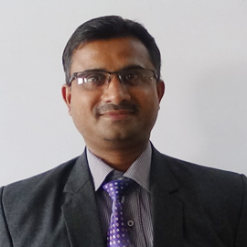 Photo
Electronics & Telecommunication Engineering

Name :- Prof. Praveen Prakashrao Likhitkar
Date of Birth :-27/08/1978
Educational Qualifications :-M.E (Digital Electronics P.T),B.E,D.E
Teaching | Research | Industrial | Others
14 | 0 | 7 Years 4 Month
Work Experience (in Yrs.)

Area of specialization :- Wireless Communication, Digital Communication SOFC
At UG Level | At PG Level
ADC,P.E,OFC,AP,MTT | WCOM,OFC
Subject Taught

Master | Ph. D
0 | 0
Research Guidance

International Journal | National Journal | International Conference | National Conference
12 | 0 | 02 | 01
No. of Papers Published in

Projects Carried out : - 12
No.of Patents :- 01
Technology Transfer :- 0
Research Publications :- 01
No. of Books published with details :- 0
No.of Copy Right :- 02

Faculty Details
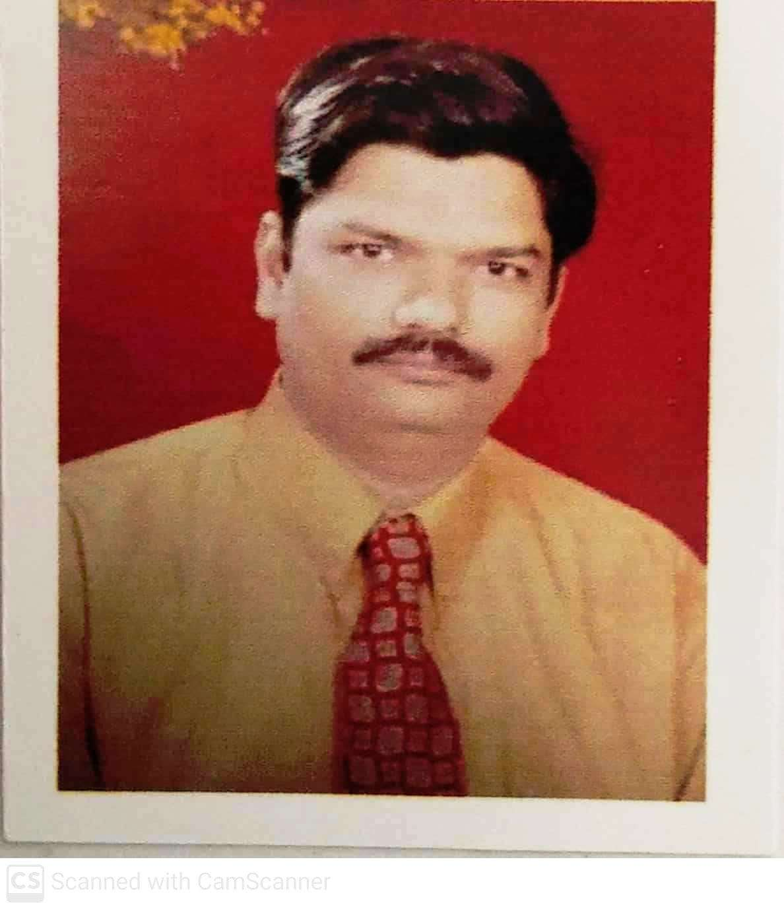Photo
Electronics & Telecommunication Engineering

Name :- Ravindra Ramkrishna Solanke
Date of Birth :- 21/02/1972
Educational Qualifications :- M.E.(E.P.S.)
Teaching | Research | Industrial | Others
11 | - | 7 | -
Work Experience (in Yrs.)

Area of specialization : - Electrical Power System.
At UG Level
P.E,BEDC,EVS
Subject Taught

Master | Ph.D
- | -
Research Guidance

International Journal | National Journal | International Conference | National Conference
2 | 1 | 4 | 1
No. of Papers Published in

Projects Carried out :- 7
Patents :-Nil
Technology Transfer :-Nil
Research Publications :- Nil
No. of Books published with details :- Nil

Faculty Details
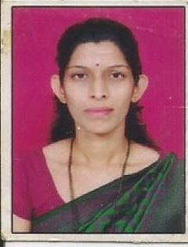
Electronics & Telecommunication Engineering

- Name :- Mrs. Rashmi A. Wakode
- Date of Birth :- 22/05/1982
- Educational Qualifications :- M.E.(Digital Electronics), PhD (Pursuing)

- Work Experience (in Yrs.)
Teaching | Research | Industrial | Others
12 yrs | ---- | 10 months | ----

- Area of specialization :- Digital Electronics
- Subject Taught
At U.G  level | At P.G  level
-Introduction to Microprocessor  -Microcontroller and Applications  -Object Oriented Programming  -Computer Architecture  - Embedded System Design  -Python Programming | Nil

- Research Guidance
Master | Ph.D
- | -

- No.of Papers Published in
International  Journal | National  Journal | International  Conference | National  Conference
08 | -- | 02 | --

- Research Publications : 04

Faculty Details
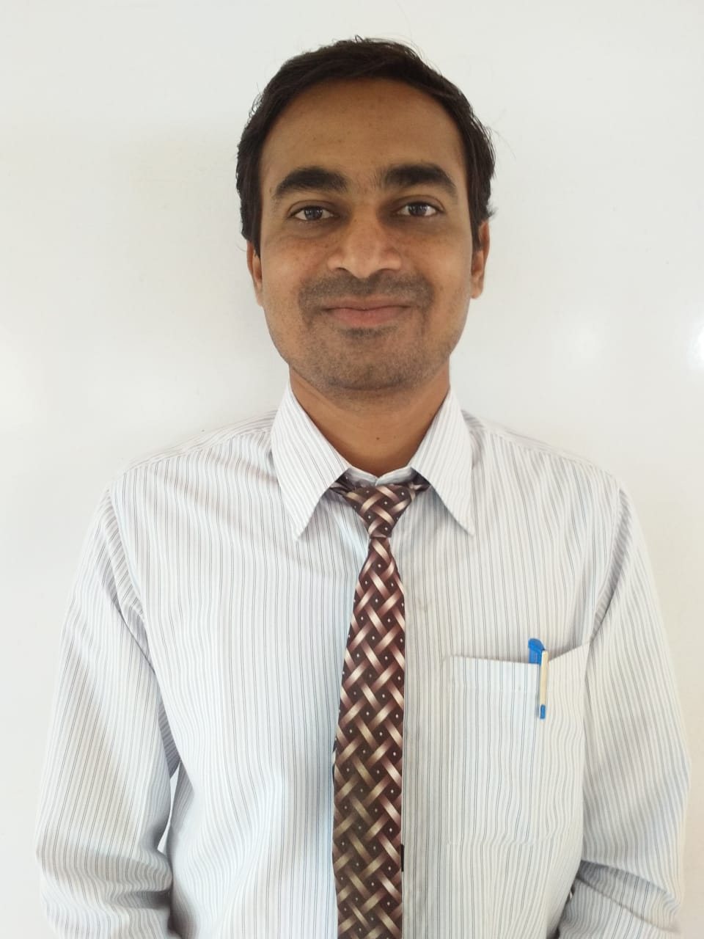

Electronics & Telecommunication Engineering

- Name :- Prof. R. S. Shriwas
- Date of Birth :- 07/04/1985
- Educational Qualifications :- Ph. D. Pursuing , M. E. ( Digital Electronics)

- Work Experience (in Yrs.)
Teaching | Research | Industrial | Others
13.5 Year

- Area of specialization :- Digital Electronics, Deep Learning
Subject Taught
At U.G  level | At P.G  level
Digital Electronics, Micro Processor & Micro controller, Object Oriented Programming, Analog Circuits

- Research Guidance
Master | Ph.D

- No. of Papers Published in
International  Journal | National  Journal | International  Conference | National  Conference
14 |  | 04

- No.of Projects Carried out :-09
- No .of Patents :- 01
- Technology Transfer :-
- Research Publications : 14
- No. of Books published with details : --
- No. of Copy right :- ----

Faculty Details
Electronics & Telecommunication Engineering
- Name :- Prof. Rahul R. Sharma
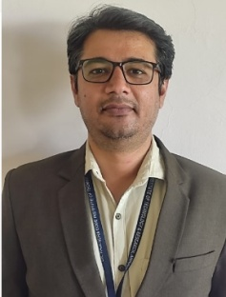

• Date of Birth :- 01/04/1986
• Educational Qualifications :- M.E (Electronics & Telecommunication)
Teaching | Research | Industrial | Others
8.5 |  | 6.5
• Work Experience (in Yrs.)

- Area of specialization Electronics & Telecommunication
At U.G  level | At P.G  level
NT, EDC, CNS, ITC, AC, DSD | NIL
- Subject Taught

Master | Ph.D
--- | --
• Research Guidance

International Journal | National Journal | International Conference | National Conference
2 | 0 | 0 | 0

• No.of Papers Published in

- No.of Projects Carried out :- 4
- No .of Patents :- 0

Faculty Details
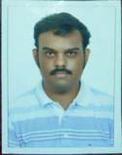hoto
Electronics & Telecommunication Engineering

Name :- Prof. Dikshant Bharat Patil
Date of Birth :- 17/12/1996
Educational Qualifications :- M.E (EXTC), BE(EXTC)
Teaching | Research | Industrial | Others
1 | 0 | 0 | 0
Work Experience (in Yrs.)

Area of specialization : - Wireless Communication
At UG Level | At PG Level
EE,EDC,ADC
Subject Taught

Master | Ph. D
0 | 0
Research Guidance

International Journal | National Journal | International Conference | National Conference
2 | 0 | 0 | 0
No. of Papers Published in

Projects Carried out :- NIL
Patents :- Nil
Technology Transfer :- Nil
Research Publications :- Nil
No. of Books published with details :- Nil

Faculty Details
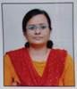
Electronics & Telecommunication Engineering

Name :- Prof. Minal S. Harne
Date of Birth :- 20/12/1979
Educational Qualifications :- ME (D.E), BE(EXTC)
Teaching | Research | Industrial | Others
2 Year 8 month | - | - | -
Work Experience (in Yrs.)

Area of specialization : - Digital Communication, Wireless Communication,Microcontroller
At UG Level | At PG Level
ADC,DSD,DSP | Nil
Subject Taught

Master | Ph. D
- | -
Research Guidance

International Journal | National Journal | International Conference | National Conference
4 | - | - | -
No. of Papers Published in

Projects carried out : 2
Patents : - Nil
Technology Transfer : - Nil
Research Publications : - Nil
No. of Books published with details : - Nil

Faculty Details
Dept. Name: Electronics & Tele. Communication Engineering
(Diploma)
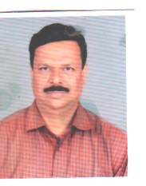
• Name :- Harshal Sumantrao Deshmukh
• Date of Birth :- 30/06/1971
• Educational Qualifications :- M.E (Digital Electronics)
Teaching | Research | Industrial | Others
12 | - | 01 | -

• Work Experience (in Yrs.)

• Area of specialization :- Digital Electronics
At U.G  level | At P.G  level | At Diploma  level
Capstone Project
Emerging Trends in Electronics
Management Linear Integrated Circuit, Mobile & Wireless Communication ,

- Subject Taught

Master | Ph.D
-- | --
• Research Guidance

International Journal | National Journal | International Conference | National Conference
02 | -- | -- | 02
• No.of Papers Published in

- No.of Projects Carried out :- 04
- No .of Patents :- NIL
- Technology Transfer :- NIL
- Research Publications :- NIL
- No. of Books published with details :- NIL
- No. of Copy right :- NIL

Faculty Details
Dept. Name: Electronics & Tele. Communication Engineering
(Diploma)
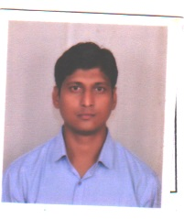
• Name :- Dhananjay Arvind Deshpande
• Date of Birth :- 15/06/1984
• Educational Qualifications :- M.Tech (Electronics & Tele. Comm. Engg)
Teaching | Research | Industrial | Others
10 | - | - | -

• Work Experience (in Yrs.)

• Area of specialization :-
At U.G  level | At P.G  level | At Diploma  level
Mechatronics
(MEC-22643),
Digital Communication System
(DCS-22428),
Entrepreneurship Development (EDE-PR-22032), Control Systems & PLC (CSP-22531), Applied Electronics
(AEL-22329)

- Subject Taught

• Research Guidance
Master | Ph.D
-- | --

International Journal | National Journal | International Conference | National Conference
03 | -- | -- | 02
• No.of Papers Published in

- No.of Projects Carried out :- 02
- No .of Patents :- NIL
- Technology Transfer :- NIL
- Research Publications :- NIL
- No. of Books published with details :- NIL
- No. of Copy right :- NIL

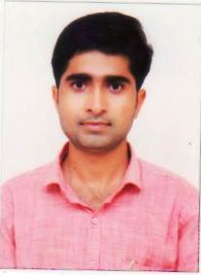
Faculty Details
Dept. Name: Electronics & Tele. Communication Engineering
(Diploma)
• Name :- Saurabh Rameshwar Chaudhari
• Date of Birth :- 20/06/1990
• Educational Qualifications :- B.E (Electronics & Tele. Comm Engg), M.E. (Appear)
Teaching | Research | Industrial | Others
11 | - | - | -

• Work Experience (in Yrs.)

• Area of specialization :- Digital Electronics
At U.G  level | At P.G  level | At Diploma  level
Computer Networking and Data Communication (CND-22634),
Microcontroller and Application (MAA-22426), Electronics Engg. Components (EMC-PR-312316),
Embedded Systems(ESY-22532), Digital Techniques(DTE-22320)
- Subject Taught

Master | Ph.D
-- | --
• Research Guidance

International Journal | National Journal | International Conference | National Conference
-- | -- | -- | 02
• No.of Papers Published in

- No.of Projects Carried out :- 02
- No .of Patents :- NIL
- Technology Transfer :- NIL
- Research Publications :- NIL
- No. of Books published with details :- NIL
- No. of Copy right :- NIL

Faculty Details
Dept. Name: Electronics & Tele. Communication Engineering
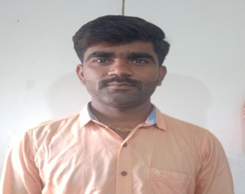
(Diploma)
• Name :- Swapnil Dnyaneshwar Sonar
• Date of Birth :- 25/01/1993
• Educational Qualifications :- B.E (Electronics & Tele. Comm. Engg)
Teaching | Research | Industrial | Others
02 | - | - | -

• Work Experience (in Yrs.)

• Area of specialization :-
At U.G  level | At P.G  level | At Diploma  level
Basic Electronics
(BEL-22216),
Electronic Engg & Components
(EMC-312316), Environmental Studies
(EST-22447), Electronic Measurements & Instrumentation(EMI-22333)
- Subject Taught

Master | Ph.D
-- | --
• Research Guidance

International Journal | National Journal | International Conference | National Conference
-- | -- | -- | 02

• No.of Papers Published in

- No. of Projects Carried out :- 02
- No .of Patents :- NIL
- Technology Transfer :- NIL
- Research Publications :- NIL
- No. of Books published with details :- NIL
- No. of Copy right :- NIL

Faculty Details
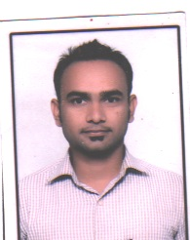
Dept. Name: Electronics & Tele. Communication Engineering
(Diploma)
• Name :- Akshay Raju Khadse
• Date of Birth :- 18/05/1992
• Educational Qualifications :- M.E (Electrical Power System)
Teaching | Research | Industrial | Others
09 | - | - | -

• Work Experience (in Yrs.)

• Area of specialization :- Electrical Power System
At U.G  level | At P.G  level | At Diploma  level
Basic Power Electronics
(BPE-22427),
Elements of Electrical Engg
(EEE-312315),
Electric Circuits & Network
(ECN-22330), Basic Electrical and Electronics Engineering
(BEE-22310)
- Subject Taught

Master | Ph.D
-- | --
• Research Guidance

International Journal | National Journal | International Conference | National Conference
-- | -- | -- | -

• No.of Papers Published in
- No.of Projects Carried out :- 02
- No .of Patents :- NIL
- Technology Transfer :- NIL
- Research Publications :- NIL
- No. of Books published with details :- NIL
- No. of Copy right :- NIL

Department of Computer Science & Engineering
Faculty List

Sr.No | Name | Qualification | Designation | Teaching Level
1. | Dr. Dipti Y. Patil | Ph.D (CSE),  M. E. (CE),  B. E. (CSE) | Head &  Professor | PG
2. | Dr. Avinash P. Jadhao | Ph.D , M. E. (CSE), B. E. (CSE) | Associate Professor | UG
3. | Prof. Swati C. Tawalare | Ph.D(CSE) pursuing ,M. E. ( IT), B. E. (CSE) | Asst. Professor | PG
4. | Prof. Dhiraj S. Kalyankar | Ph.D (CSE) Pursuing , M. E. (CS& IT), B. E. (CSE) | Asst. Professor | UG
5. | Prof. Samata V. Athawale | M. E. (CSIT),  B. E. (CSE) | Asst. Professor | UG
6. | Prof. Devendra S. Ingale | M. E. (CS& IT),  B. E. (CSE) | Asst. Professor | UG
7. | Prof. Chaya C. Gudade | M-Tech (DS), B. E. (CSE) | Asst. Professor | UG
8. | Prof. Renu K. Pawar | M. E. (CSIT), B. E. (IT) | Asst. Professor | UG
9. | Prof. Priti N. Wake | M. E. (CSE), B. E. (CSE) | Asst. Professor | UG
10. | Prof. Sachin M. Inzalkar | M. E. (CSE), B. E. (CSE) | Asst. Professor | UG
11 | Prof. Snehal V. Raut | M. E. (CE), M.B.A(HRM), B. E. (CE) | Asst. Professor | UG

Name | :- | Dr. Dipti Y. Patil
Date of Birth  Educational Qualifications | :-  :- | 14/06/1975  Ph.D (CSE), M. E. (CE), B. E. (CSE)
Work Experience (in Yrs.) | Te | eaching | Research | Industrial | Others
 |  | 23 | - | - | -
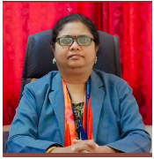
Area of specialization :- Cloud Computing
Courses Taught:-
At UG Level :- Cloud Computing, Human machine interaction,mobile computing,multimedia Systems,E-commerce,Computer Graphics,Discrete Structure,’C’ Programming
At PG Level:- Virtualisation & Cloud Computing ,E-business

Research Guidance
Master | Ph. D
20 | 02

No. of Papers Published in
International  Journal | National  Journal | International  Conference | National  Conference
25 | 04 | 15 | 03

Projects Carried out | :- | 0
Patents | :- | 04
Research Publications | :- | 52
No. of Books published with details | :- | 01

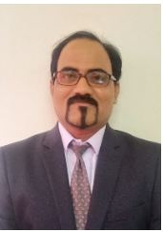

Name | :- | Dr. Avinash P. Jadhao
Date of Birth  Educational Qualifications | :-  :- | 16/12/1974  Ph.D , M. E. (CSE), B. E. (CSE)
Work Experience (in Yrs.) | Te | eaching | Research | Industrial | Others
 |  | 21 | - | 03 | -

Area of specialization :- Database
Courses Taught :-
At UG Level: - OOAD,SPG,Mobile Computing ,DBMS,CC,CD, Web technologies,Computer Architecture,OOP,SE
At PG Level: - Database Processing, Advance Computer Technique

Research Guidance
Master | Ph. D
04 | 0

No. of Papers Published in
International  Journal | National  Journal | International  Conference | National  Conference
25 | 05 | 10 | 01

Projects Carried out | :- | 0
Patents | :- | 03
Research Publications | :- | 35
No. of Books published with details | :- | NIL

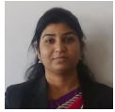
Name | :- | Prof. Swati C. Tawalare
Date of Birth  Educational Qualifications | :-  :- | 18/05/1986  Ph.D(CSE) pursuing ,M. E. ( IT), B. E. (CSE)
Work Experience (in Yrs.) | Te | eaching | Research | Industrial | Others
 |  | 11 | - | - | -

Area of specialization :- Networking, Data Mining
Courses Taught :-
At UG Level:- DSA, DBMS, DCN, DATA MINING

Research Guidance
Master | Ph. D
0 | 0

No. of Papers Published in
International  Journal | National  Journal | International  Conference | National  Conference
10 | 00 | 04 | 01

Projects Carried out | :- | 02
Patents | :- | NIL
Research Publications | :- | 12
No. of Books published with details | :- | NIL

Name | :- | Prof. Dhiraj S. Kalaynkar |  |  | 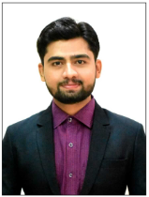
Date of Birth  Educational Qualifications | :-  :- | 19/05/1993  Ph.D (CSE) Pursuing , M. E. (CS& IT), B. E. (CSE)
Work Experience (in Yrs.) | Te | eaching | Research | Industrial | Others
 |  | 4.8 | - | - | -

Area of specialization :- Networking
Courses Taught :-
At UG Level:- OS, DBMS, SSEE,DSA,EVS,

Research Guidance
Master | Ph. D
0 | 0

No. of Papers Published in
International  Journal | National  Journal | International  Conference | National  Conference
16 | 0 | 04 | 0

Projects Carried out | :- | 0
Patents | :- | 01
Research Publications | :- | 20
No. of Books published with details | :- | NIL

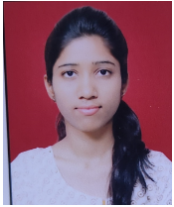

Name | :- | Prof. Samata V. Athawale
Date of Birth  Educational Qualifications | :-  :- | 10/07/1995  M. E. (CSIT), B. E. (CSE)
Work Experience (in Yrs.) | Te | eaching | Research | Industrial | Others
 |  | 05 | - | - | -

Area of specialization :- Compiler, Algorithm,Data mining
Courses Taught:-
At UG Level:- CD,DAA,SE,OS,Programming Languages

Research Guidance
Master | Ph. D
0 | 0

No. of Papers Published in
International  Journal | National  Journal | International  Conference | National  Conference
06 | 00 | 02 | 00

Projects Carried out | :- | 0
Patents | :- | NIL
Research Publications | :- | 04
No. of Books published with details | :- | NIL

Name | :- | Prof. Devendra S. Ingale |  |  | 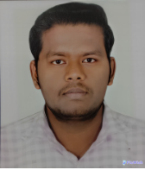
Date of Birth  Educational Qualifications | :-  :- | 22/02/1998  M. E. (CS& IT), B. E. (CSE)
Work Experience (in Yrs.) | Te | aching | Research | Industrial | Others
 |  | 0.6 | - | - | -

Area of specialization :- Database ,Programming
Courses Taught:-
At UG Level:- VAR,CPR,

Research Guidance
Master | Ph. D
0 | 0

No. of Papers Published in
International  Journal | National  Journal | International  Conference | National  Conference
02 | 02 | 0 | 0

Projects Carried out | :- | 06
Patents | :- | NIL
Research Publications | :- | 04
No. of Books published with details | :- | NIL

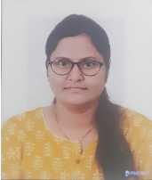
Name | :- | Prof. Chaya C. Gudade
Date of Birth  Educational Qualifications | :-  :- | 27/11/1984  M-Tech (DS), B. E. (CSE)
Work Experience (in Yrs.) | Te | eaching | Research | Industrial | Others
 |  | 0.6 | - | - | -

Area of specialization :- Compiler, Algorithm,Data mining
Courses Taught:-
At UG Level :- EM,AI,

Research Guidance
Master | Ph. D
0 | 0

No. of Papers Published in
International  Journal | National  Journal | International  Conference | National  Conference
02 | 00 | 02 | 00

Projects Carried out | :- | 0
Patents | :- | NIL
Research Publications | :- | 02
No. of Books published with details | :- | NIL

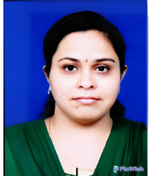

Name | :- | Prof. Renu K. Pawar
Date of Birth  Educational Qualifications | :-  :- | 30/10/1984  M. E. (CSIT), B. E. (IT)
Work Experience (in Yrs.) | Te | eaching | Research | Industrial | Others
 |  | 02 | - | - | -

Area of specialization :- MALP
Courses Taught:-
At UG Level :- MALP,CRP,DBMS,COMPUTER NETWORK

Research Guidance
Master | Ph. D
0 | 0

No. of Papers Published in
International  Journal | National  Journal | International  Conference | National  Conference
01 | 00 | 00 | 00

Projects Carried out | :- | 02
Patents | :- | NIL
Research Publications | :- | 01
No. of Books published with details | :- | NIL

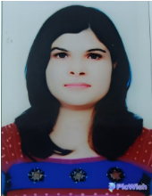
Faculty Details Computer Science & Engineering

Name | :- | Prof. Priti N. Wake
Date of Birth  Educational Qualifications | :-  :- | 02/11/1984  M. E. (CSE), B. E. (CSE)
Work Experience (in Yrs.) | Te | eaching | Research | Industrial | Others
 |  | 7 | - | - | -

Area of specialization :- Networking
Courses Taught:-
At UG Level :- DCN,PEM,DBMS,PM,CG,SE

Research Guidance
Master | Ph. D
0 | 0

No. of Papers Published in
International  Journal | National  Journal | International  Conference | National  Conference
01 | 02 | 00 | 00

Projects Carried out | :- | 02
Patents | :- | NIL
Research Publications | :- | 03
No. of Books published with details | :- | NIL

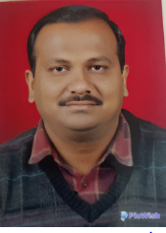
Faculty Details Computer Science & Engineering
Name | :- | Prof. Sachin M. Inzalkar
Date of Birth  Educational Qualifications | :-  :- | 21/07/1984  M. E. (CSE), B. E. (CSE)
Work Experience (in Yrs.) | Te | eaching | Research | Industrial | Others
 |  | 10 | - | - | -

Area of specialization :-Web Technologies
Courses Taught:-
At UG Level:- DBMS,DLT,TOC,CD,SE

Research Guidance
Master | Ph. D
0 | 0

No. of Papers Published in
International  Journal | National  Journal | International  Conference | National  Conference
10 | 05 | 05 | 00

Projects Carried out | :- | 0
Patents | :- | NIL
Research Publications | :- | 20
No. of Books published with details | :- | NIL

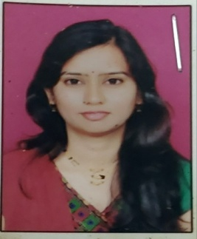
Faculty Details Computer Science & Engineering

Name | :- | Prof. Snehal V. Raut
Date of Birth  Educational Qualifications | :-  :- | 25/03/1987  M. E. (CE), M.B.A(HRM), B. E. (CE)
Work Experience (in Yrs.) | Te | eaching | Research | Industrial | Others
 |  | 0.6 yr | - | 2 yr | -

Area of specialization :- C, Java,C++, PHP
Courses Taught: - Programming Languages

Research Guidance
Master | Ph. D
0 | 0

No. of Papers Published in
International  Journal | National  Journal | International  Conference | National  Conference
06 | 02 | 0 | 0

Projects Carried out | :- | 0
Patents | :- | NIL
Research Publications | :- | 10
No. of Books published with details | :- | NIL

Department: First Year Engineering
Faculty List
Sr.No. | Name | Qualification | Designation | Teaching Level
1 | Dr. Shrikant Devendra Thakre | M.Sc, B.Ed, Ph.D | Head & Associate  Professor | UG
2 | Ashvini Dhanraj Nakhale | M.Sc (Maths) | Asst. Professor | UG
3 | Harshal Ashokrao Nimkar | M.Sc. (Maths)B.Ed, | Asst. Professor | UG
4 | Ankit Shyamkumarji Dixit | M.Sc (Chem) | Asst. Professor | UG
5 | Manoj Pramodrao Khere | M.Sc (Maths) | Asst. Professor | UG
6 | Chetan Gajanan Panchwate | M.Sc. (Phy) B.Ed | Asst. Professor | UG
7 | Milind Sheshrao Bodkhe | M.E. (PTM), MBA (HR) | Asst. Professor | UG
8 | Nitin Nayaranrao Morey | M.E. (Civil) | Asst. Professor | UG
9 | Vaishnavee Dnyaneshwar Guhe | M.E. (EPS) | Asst. Professor | UG
10 | Deepa Shankarrao Deulkar | M.Tech (CSE) | Asst. Professor | UG
11 | Shivani Gajananrao Dharmale | M.Tech (EXTC) | Asst. Professor | UG
12 | Neha Sanjay Varma | M.Sc. (Chem) | Asst. Professor | UG
13 | Miss. Deepashree Deshmukh | M.Sc, B.Ed | Lecturer | Diploma
14 | Miss. Meera Raut | M.A (English), B.Ed | Lecturer | Diploma
15 | Ambika R.Sonar | M.Sc. (Physics), B.ed | Lecturer | Diploma
16 | Miss. Mayuri D. Borkar | M.Sc. (Mathematics),B.ed. | Lecturer | Diploma
17 | Dipali Sudhakarrao Fadke | M.SC. Chemistry | Lecturer | Diploma
18 | Roshan Tukappa Misal | B.E. (Computer Engg.) | Lecturer | Diploma
19 | Raj Ratan Borkar | B.E. (Computer Engg.) | Lecturer | Diploma
20 | Ashish A.Burghate | B.E. (Computer Engg.) | Lecturer | Diploma
21 | Rushikesh D.Bazare | B.E. (Computer Engg.) | Lecturer | Diploma

Faculty Details
Department of Applied Science & Humanities
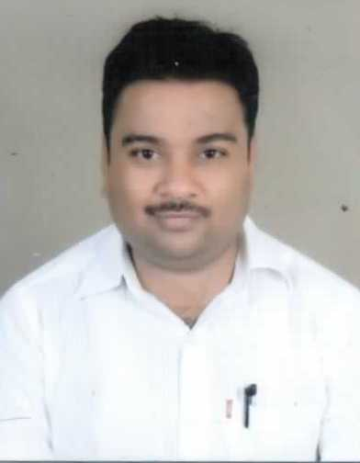
• Name :- Dr. Shrikant Devendra Thakre
• Date of Birth :- 30/06/1983
• Educational Qualifications :- M.Sc., B.Ed. Ph. D.
Teaching | Research | Industrial | Others
16 | --- | --- | ---

• Work Experience (in Yrs.)

• Area of specialization :- Physics
At U.G  level | At P.G  level
Engineering Physics | ------
- Subject Taught

Master | Ph. D.
---- | --
• Research Guidance

International Journal | National Journal | International Conference | National Conference
06 | 01 | 02 | 01
• No. of Papers Published in

- No. of Projects Carried out :- ----
- No .of Patents :- 01
- Technology Transfer :- -----
- Research Publications :- 08
- No. of Books published with details :- ----
- No. of Copy right :- 01
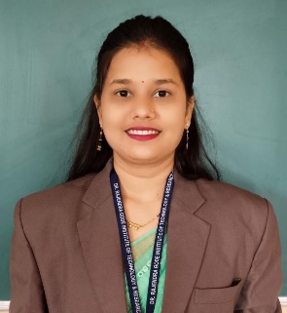
Faculty Details
Department of Applied Science and Humanities

• Name :- Ashvini Dhanraj Nakhale
• Date of Birth :- 30/05/1996
• Educational Qualifications :- B.Sc., M. Sc. mathematics. B. Ed.

Teaching | Research | Industrial | Others
6 | - | - | 1

• Work Experience (in Yrs.)

• Area of specialization :- Applied Mathematics
At U.G  level | At P.G  level
Engineering Math-I Engineering Math-II, Engineering Math-III  Remedial Mathematics (CoP and IOP)  Descrete Mathematics (Diploma) | -
- Subject Taught

Master | Ph.D
- | --
• Research Guidance

International Journal | National Journal | International Conference | National Conference
1 | - | - | -

• No. of Papers Published in

- No. of Projects Carried out :- Nil
- No .of Patents :- Nil
- Technology Transfer :- Nil
- Research Publications :- Nil
- No. of Books published with details :- Nil
- No. of Copy right :- 01

Faculty Details
Department of Applied Science and Humanities
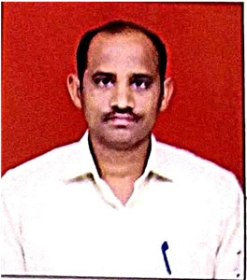

• Name :- Mr. Harshal A. Nimkar
• Date of Birth :- 05/07/1991
• Educational Qualifications :- M. Sc (Mathematics),B. Ed , Ph. D (Pursuing)
Teaching | Research | Industrial | Others
2 years | - | - | -

• Work Experience (in Yrs.)

• Area of specialization :- Pure Mathematics
At U.G  level | At P.G  level
- Engineering Mathematics I  - Engineering Mathematics II  - Engineering Mathematics III | -
- Subject Taught

Master | Ph.D
- | --
• Research Guidance

International Journal | National Journal | International Conference | National Conference
01 | 02 | - | -

• No. of Papers Published in

- No. of Projects Carried out :- Nil
- No .of Patents :- Nil
- Technology Transfer :- Nil
- Research Publications :- 03
- No. of Books published with details :- Nil
- No. of Copy right :- Nil

Faculty Details
Department of Applied Science and Humanities
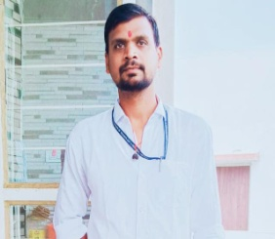
• Name :- Ankit Shyamkumarji Dixit
• Date of Birth :- 26 /10/1990
• Educational Qualifications :- M. Sc (Chemistry), Pursuing Ph.D.
Teaching | Research | Industrial | Others
8 | - | - | -

• Work Experience (in Yrs.)

• Area of specialization :- Organic Chemistry
At U.G  level | At P.G  level
ENGINEERING CHEMISTRY | -
- Subject Taught

Master | Ph. D.
-- | --
• Research Guidance

International Journal | National Journal | International Conference | National Conference
- | - | 2 | 2

• No. of Papers Published in

- No. of Projects Carried out :- -
- No .of Patents :- -
- Technology Transfer :- -
- Research Publications :- -
- No. of Books published with details :- -
- No. of Copy right :- -

Faculty Details
Department of Applied Science and Humanities
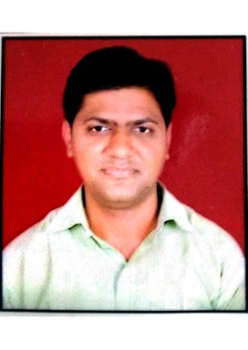
• Name :- Manoj P. Khere
• Date of Birth :- 04 /01/1986
• Educational Qualifications :- M. Sc (Mathematics), Ph.D. pursuing
Teaching | Research | Industrial | Others
9 | - | - | -

• Work Experience (in Yrs.)

• Area of specialization :- Complex Analysis And Operator Theory
At U.G  level | At P.G  level
Engineering Mathematics | --
- Subject Taught

Master | Ph. D.
-- | --
• Research Guidance

International Journal | National Journal | International Conference | National Conference
1 | - | 1 | 2

• No. of Papers Published in

- No. of Projects Carried out :- -
- No .of Patents :- -
- Technology Transfer :- -
- Research Publications :- -
- No. of Books published with details :- -
- No. of Copy right :- -

Faculty Details
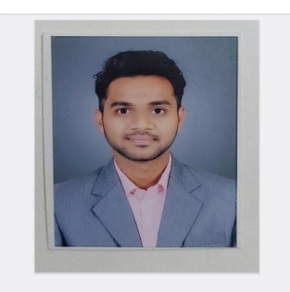
Department of Applied Science and Humanities
• Name :- Mr. Chetan Gajanan Panchwate
• Date of Birth :- 20/03/1997
• Educational Qualifications :- B. Sc., M. Sc., B. Ed.
Teaching | Research | Industrial | Others
3 | - | - | 2

• Work Experience (in Yrs.)

• Area of specialization :- condensed matter physics
At U.G  level | At P.G  level
Engg. Physics subject On First year engineering  Laser and semiconductors On B.sc semester pattern | Classical Mechanics, Nano science and nanotechnology & condensed matter physics Lesson taught On M.Sc physics semester
- Subject Taught

Master | Ph. D.
1 | --
• Research Guidance

International Journal | National Journal | International Conference | National Conference
- | - | - | -

• No. of Papers Published in

- No. of Projects Carried out :-
- No .of Patents :-
- Technology Transfer :-
- Research Publications :-
- No. of Books published with details :-
- No. of Copy right :-

Faculty Details
Department of Applied Science and Humanities
• Name :- Mr. Milind Sheshrao Bodkhe
• Date of Birth :- 04/01/1975
• Educational Qualifications :- B.E (Mechanical. Engg.), M. E (Prod. Tech. & Management),
MBA (HR)
Teaching | Research | Industrial | Others
24 | -- | 02
• Work Experience (in Yrs.)

• Area of specialization :- Production Technology and Management
At U.G  level | At P.G  level
- Engineering Drawing.  - Mechanical Engineering Drawing.  - Manufacturing process-I  - Manufacturing process-II  - Automobile Engineering.  - Industrial organization & Management  - Communication skills  - Production Management | Nil
- Subject Taught

• Research Guidance- To Post Graduate M.E (CAD/CAM)
• No. of Papers Published in
International Journal | National Journal | International Conference | National Conference
- | - | 4 | 10

- No. of Projects Carried out
- No .of Patents :- Nil
- Technology Transfer :- Nil
- Research Publications :- Nil
- No. of Books published with details :- Nil
- No. of Copy right :- Nil

Faculty Details
Department of Applied Science & Humanities

• Name :- Mr. Nitin N. Morey
• Date of Birth :- 26/07/1983
• Educational Qualifications :- Ph.D. (Pursuing), M. E. (Civil), B. E., D.C.E.
Teaching | Research | Industrial | Others
12.5 | --- | 01 | ---

• Work Experience (in Yrs.)

• Area of specialization :- Structures
At U.G  level | At P.G  level
Engineering Mechanics, Strength of Materials, Structural Analysis, Concrete Technology, Structural Design | ---
- Subject Taught

Master | Ph. D.
12 | ---
• Research Guidance

International Journal | National Journal | International Conference | National Conference
16 | --- | 03 | 01

• No. of Papers Published in

- No. of Projects Carried out :- 01
- No .of Patents :- 03
- Technology Transfer :- Nil
- Research Publications :- 20
- No. of Books published with details :- Nil
- No. of Copy right :- Nil

Faculty Details
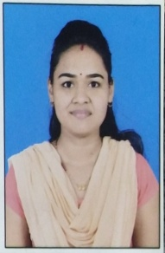
Department of Applied Science and Humanities

• Name :- Vaishnavee Dnyaneshwar Guhe
• Date of Birth :- 04 April 1994
• Educational Qualifications :- ME (Electrical Power System), BE (Electronics & Power )

Teaching | Research | Industrial | Others
05 years | - | - | -

• Work Experience (in Yrs.)

• Area of specialization :-
At U.G  level | At P.G  level
Basic Electrical Engineering

- Subject Taught

Master | Ph. D.
 | --
• Research Guidance

International Journal | National Journal | International Conference | National Conference
1 | 1 | - | 1

• No. of Papers Published in

- No. of Projects Carried out :- 1
- No .of Patents :-
- Technology Transfer :-
- Research Publications :-
- No. of Books published with details :-
- No. of Copy right :-
Faculty Details
Department of Applied Science and Humanities
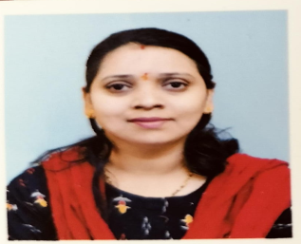
• Name :- Deepa Shankarrao Deulkar
• Date of Birth :- 13/10/1989
• Educational Qualifications :- M. Tech( Computer Science and Engineering)
Teaching | Research | Industrial | Others
3 | - | - | -

• Work Experience (in Yrs.)

• Area of specialization :-
At U.G  level | At P.G  level
Computer programming
- Subject Taught

Master | Ph. D.
 | --

• Research Guidance
International Journal | National Journal | International Conference | National Conference
1 | 1

• No. of Papers Published in

- No. of Projects Carried out :- 2
- No .of Patents :-
- Technology Transfer :-
- Research Publications :-
- No. of Books published with details :-
- No. of Copy right :-
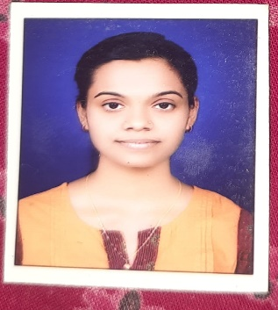
Faculty Details
Department of Applied Science & Humanities
• Name :- Ms. Shivani G. Dharmale
• Date of Birth :- 10/10/1993
• Educational Qualifications :- M. Tech ( Communication Engg.)
Teaching | Research | Industrial | Others
6 Yrs | --- | ---- | ----

• Work Experience (in Yrs.)

• Area of specialization :-
At U.G  level | At P.G  level
EDC
Digital Communication
Analog & Digital Electronics (CSE)
Electrical Engineering

- Subject Taught

Master | Ph. D.
-- | --
• Research Guidance

International Journal | National Journal | International Conference | National Conference
4 | 1
• No. of Papers Published in

- No. of Projects Carried out :- 2
- No .of Patents :- 1
- Technology Transfer :-
- Research Publications :- 1
- No. of Books published with details :-
- No. of Copy right :-

Faculty Details
Department of Applied Science and Humanities
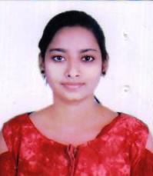
• Name :- Miss. Neha Varma
• Date of Birth :- 16/08/1995
• Educational Qualifications :- M. Sc (Chemistry),B. Ed
Teaching | Research | Industrial | Others
2 years | - | - | -

• Work Experience (in Yrs.)

• Area of specialization :- Pure Mathematics
At U.G  level | At P.G  level
Engineering Chemistry | -
- Subject Taught

Master | Ph. D.
- | --
• Research Guidance

International Journal | National Journal | International Conference | National Conference
- | - | - | -

• No. of Papers Published in

- No. of Projects Carried out :- Nil
- No .of Patents :- Nil
- Technology Transfer :- Nil
- Research Publications :- Nil
- No. of Books published with details :- Nil
- No. of Copy right :- Nil

Faculty Details
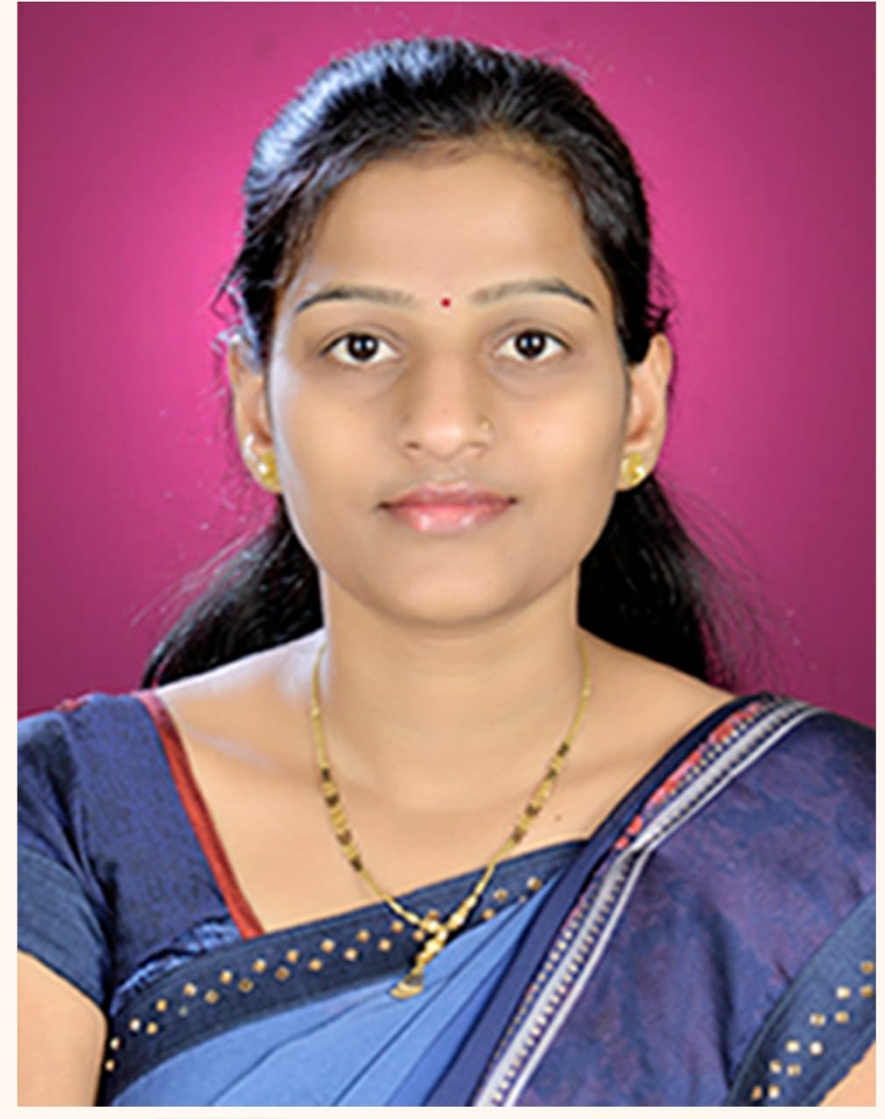
Dept. Name: Science & Humanities (Polytechnic)

• Name : - Ms.Deepashree R. Deshmukh
• Date of Birth : - 30/10/1986
• Educational Qualifications : - M.SC. Chemistry, M.Phill, Ph.d Pursuing
Teaching | Research | Industrial | Others
14

• Work Experience (in Yrs.)

• Area of specialization :- Chemistry
At U.G  level | At P.G  level | At Diploma  level
Engg. chemistry |  | Basic chemistry,  Applied chemistry.
- Courses Taught

Master | Ph.D
-- | --
• Research Guidance

International Journal | National Journal | International Conference | National Conference
-- | 03 | -- | 05
•No.of Papers Published in

- No. ofProjects Carried out :-NIL
- No .of Patents :- NIL
- Technology Transfer :- NIL
- Research Publications :- NIL
- No. of Books published with details :- NIL
- No. of Copy right :- NIL

Faculty Details
Dept. Name: Science & Humanities (Polytechnic)
• Name : - Ms. Meera N.Raut 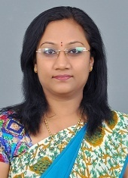
• Date of Birth : - 17/12/1983
• Educational Qualifications : - MA (English Literature), M.phil , Ph.d (persuing)
Teaching | Research | Industrial | Others
15 | -- | -- | --

• Work Experience (in Yrs.)

• Area of specialization :- English, Communication Skills
At U.G  level | At P.G  level | At Diploma  level
Communication Skills |  | English,  Professional Communication
- Courses Taught

Master | Ph.D
-- | --
• Research Guidance

International Journal | National Journal | International Conference | National Conference
-- | -- | --- | --

•No.of Papers Published in

- No. of Projects Carried out :-NIL
- No .of Patents :- NIL
- Technology Transfer :- NIL
- Research Publications :- NIL
- No. of Books published with details :- NIL
- No. of Copy right :- NIL
Faculty Details
Dept. Name: Science & Humanities (Polytechnic)
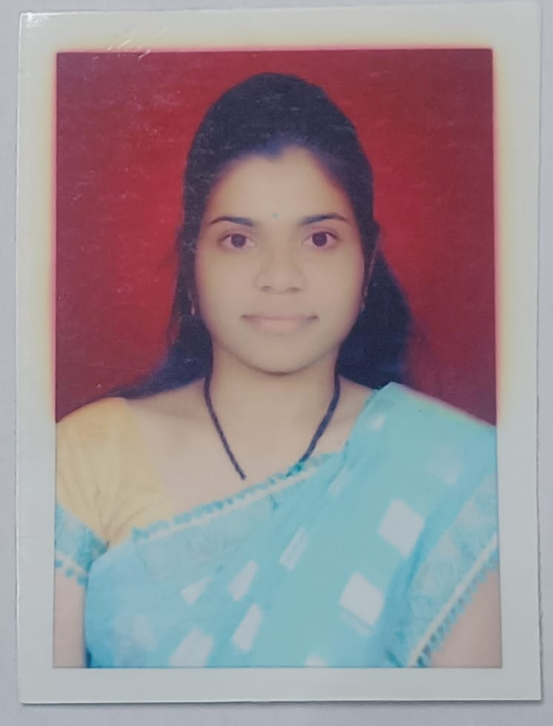

• Name : - Mayuri Devidas Borkar
• Date of Birth : - 27/08/1993
• Educational Qualifications : - M.Sc. (Mathematics),B.ed.
Teaching | Research | Industrial | Others
5.5 | -- | -- | --

• Work Experience (in Yrs.)

• Area of specialization :- Mathematics
At U.G  level | At P.G  level | At Diploma  level
Engg. Mathematics |  | Basic Mathematics,  Applied Mathematics.
- Courses Taught

Master | Ph.D
-- | --
• Research Guidance

International Journal | National Journal | International Conference | National Conference
01 | -- | -- | 02

•No.of Papers Published in

- No. of Projects Carried out :-NIL
- No .of Patents :- NIL
- Technology Transfer :- NIL
- Research Publications :- NIL
- No. of Books published with details :- NIL
- No. of Copy right :- NIL

Faculty Details
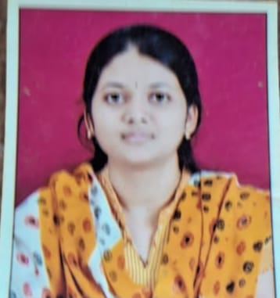
Dept. Name: Science & Humanities (Polytechnic)

• Name : - Dipali Sudhakarrao Fadke
• Date of Birth : - 22/06/1985
• Educational Qualifications : - M.SC. Chemistry
Teaching | Research | Industrial | Others
0.3 year | -- | -- | --

• Work Experience (in Yrs.)

• Area of specialization :- Chemistry
At U.G  level | At P.G  level | At Diploma  level
 |  | Basic Chemistry
- Courses Taught

Master | Ph.D
-- | --
• Research Guidance

International Journal | National Journal | International Conference | National Conference
-- | -- | -- | --

•No.of Papers Published in

- No. of Projects Carried out :-NIL
- No .of Patents :- NIL
- Technology Transfer :- NIL
- Research Publications :- NIL
- No. of Books published with details :- NIL
- No. of Copy right :- NIL

Faculty Details
Dept. Name: Science & Humanities (Polytechnic)
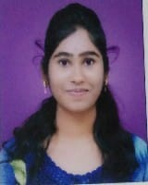
• Name : - Ambika R.Sonar
• Date of Birth : - 05/08/1998
• Educational Qualifications : - M.Sc. (Physics), B.ed
Teaching | Research | Industrial | Others
3.5 Year | -- | -- | --

• Work Experience (in Yrs.)

• Area of specialization :- Physics
At U.G  level | At P.G  level | At Diploma  level
Engineering Physics |  | Basic Physics,  Applied Physics.
- Courses Taught

Master | Ph.D
-- | --
• Research Guidance

International Journal | National Journal | International Conference | National Conference
-- | -- | -- | --

•No.of Papers Published in

- No. of Projects Carried out :-NIL
- No .of Patents :- NIL
- Technology Transfer :- NIL
- Research Publications :- NIL
- No. of Books published with details :- NIL
- No. of Copy right :- NIL
Faculty Details
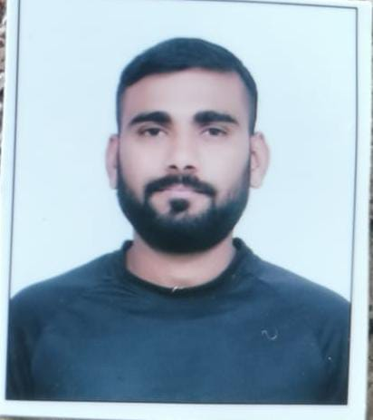
Dept. Name: Science & Humanities (Polytechnic)

• Name : - Roshan Tukappa Misal
• Date of Birth : - 30/03/1998
• Educational Qualifications : - B.E.(Computer Engg.)
Teaching | Research | Industrial | Others
0.3 | -- | -- | --

• Work Experience (in Yrs.)

• Area of specialization :- Computer Science
At U.G  level | At P.G  level | At Diploma  level
 |  | C-Programming
- Courses Taught

Master | Ph.D
-- | --
• Research Guidance

International Journal | National Journal | International Conference | National Conference
-- | -- | -- | --

•No.of Papers Published in

- No. of Projects Carried out :-NIL
- No .of Patents :- NIL
- Technology Transfer :- NIL
- Research Publications :- NIL
- No. of Books published with details :- NIL
- No. of Copy right :- NIL

Faculty Details
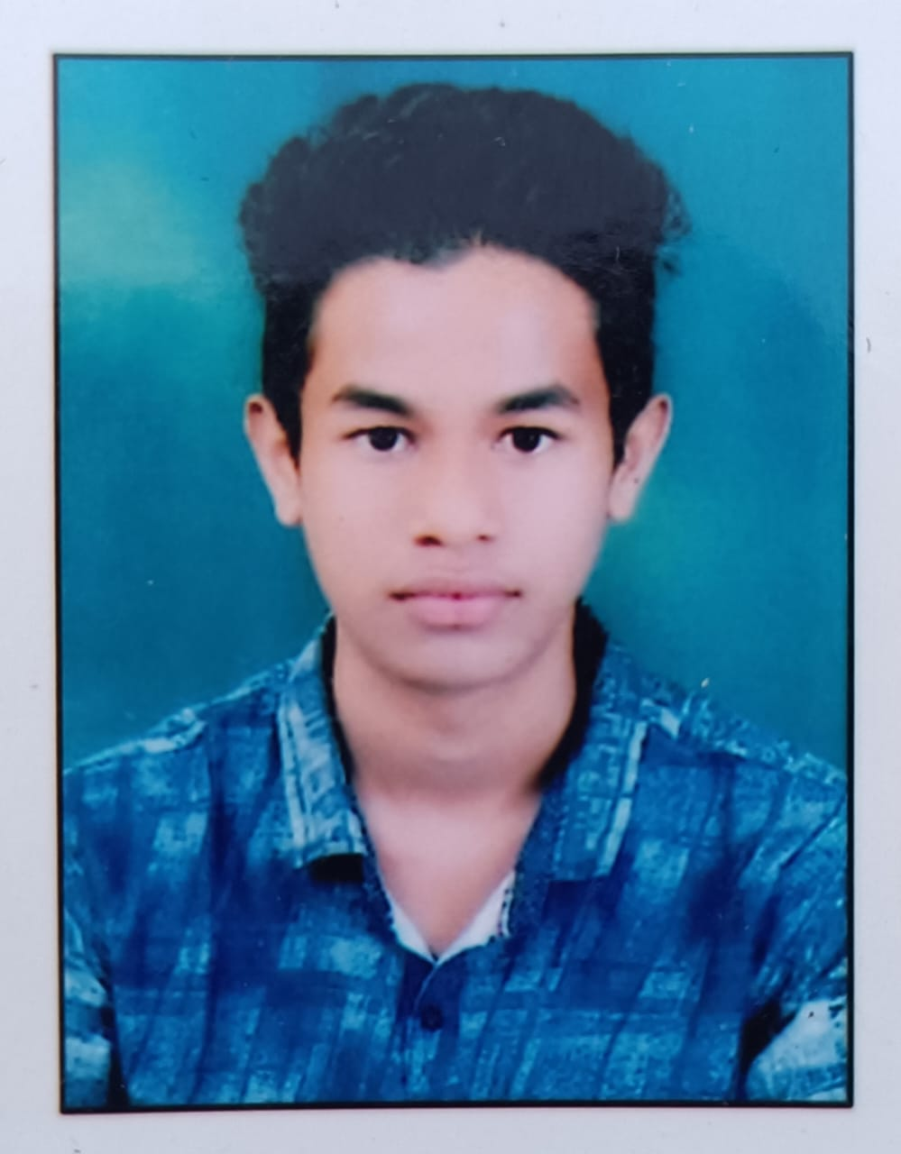
Dept. Name: Science & Humanities (Polytechnic)
• Name : - Raj Ratan Borkar
• Date of Birth : - 27/08/2001
• Educational Qualifications : - B.E.(Computer Engg.)
Teaching | Research | Industrial | Others
-- | -- | -- | --

• Work Experience (in Yrs.)

• Area of specialization :- Computer Science
At U.G  level | At P.G  level | At Diploma  level
- Courses Taught

Master | Ph.D
-- | --
• Research Guidance

International Journal | National Journal | International Conference | National Conference
-- | -- | -- | --

•No.of Papers Published in

- No. of Projects Carried out :- NIL
- No .of Patents :- NIL
- Technology Transfer :- NIL
- Research Publications :- NIL
- No. of Books published with details :- NIL
- No. of Copy right :- NIL

Faculty Details
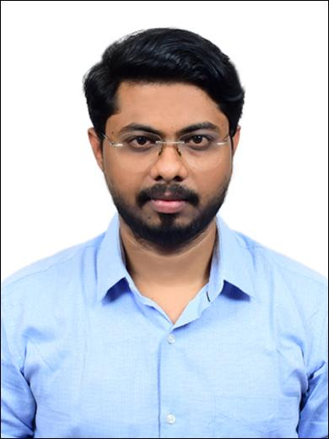
Dept. Name: Science & Humanities (Polytechnic)
• Name : - Ashish A.Burghate
• Date of Birth : - 04/04/1994
• Educational Qualifications : - B.E. (Computer Engg.)
Teaching | Research | Industrial | Others
-- | -- | -- | --

• Work Experience (in Yrs.)

• Area of specialization :- Computer Science
At U.G  level | At P.G  level | At Diploma  level
- Courses Taught

Master | Ph.D
-- | --
• Research Guidance

International Journal | National Journal | International Conference | National Conference
-- | -- | -- | --
•No.of Papers Published in

- No. of Projects Carried out :- NIL
- No .of Patents :- NIL
- Technology Transfer :- NIL
- Research Publications :- NIL
- No. of Books published with details :- NIL
- No. of Copy right :- NIL

Faculty Details
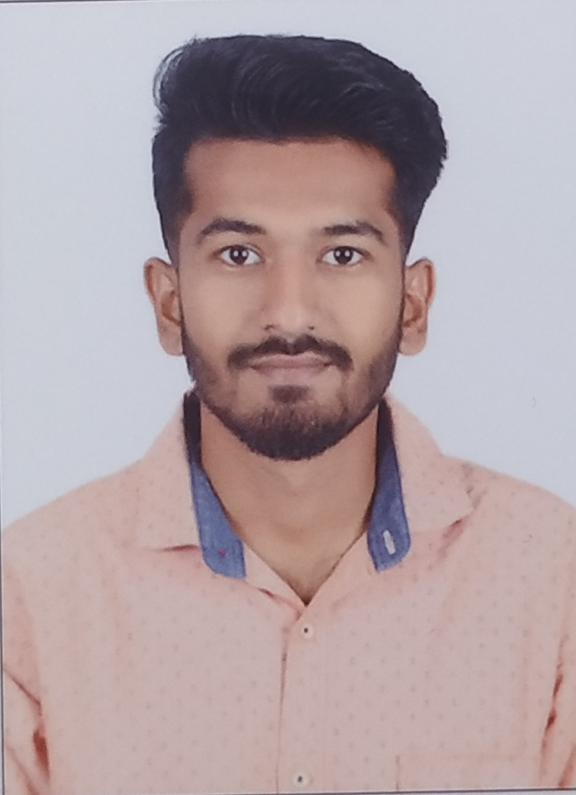
Dept. Name: Science & Humanities (Polytechnic)
• Name : - Rushikesh D.Bazare
• Date of Birth : - 08/08/1998
• Educational Qualifications : - B.E. (Computer Engg.)
Teaching | Research | Industrial | Others
-- | -- | -- | --

• Work Experience (in Yrs.)

• Area of specialization :- Computer Science
At U.G  level | At P.G  level | At Diploma  level
- Courses Taught

Master | Ph.D
-- | --
• Research Guidance

International Journal | National Journal | International Conference | National Conference
-- | -- | -- | --
•No.of Papers Published in

- No. of Projects Carried out :- NIL
- No .of Patents :- NIL
- Technology Transfer :- NIL
- Research Publications :- NIL
- No. of Books published with details :- NIL
- No. of Copy right :- NIL

Fee:-
Details of fee, as approved by State Fee Committee, for the Institution:-

Sr. No | Course Year | Admitted Year | Fee Type | SC/ST | SBC/VJ/NT/TFWS | OBC | OPEN
1 | First Year B.E | 2023-24 | Tuition fee | 0 | 0 | 37434 | 74867
2 |  |  | Development Fee | 0 | 9133 | 9133 | 9133
3 |  |  | University Fee | 300 | 300 | 300 | 300
4 |  |  | Amartya Insurance | 701 | 701 | 701 | 701
Total |  |  |  | 1001 | 10134/- | 47568/- | 85001/-

Sr. No | Course Year | Admitted Year | Fee Type | SC/ST | SBC/VJ/NT/TFWS | OBC | OPEN
1 | First Year M.E | 2023-24 | Tuition fee | 0 | 102745 | 102745 | 102745
2 |  |  | Development Fee | 0 | 13255 | 13255 | 13255
3 |  |  | University Fee | 300 | 300 | 300 | 300
Total |  |  |  | 300 | 116300/- | 116300/- | 1,16,300/-

Sr. No. | Course Year | Admitted Year | Fee Type | SC/ST | SBC/VJ/NT/TFWS | OBC | OPEN
01 | First Year  Diploma | 2023-2024 | Tuition Fee | - | - | 23,182 | 46364
02 |  |  | Development Fees | - | 4636 | 4636 | 4636
03 |  |  | Amartya Insurance | 343 | 343 | 343 | 343
 |  | Total |  | 343 | 4979/- | 28,161/- | 51,343/-

Time schedule for payment of fee for the entire programme :-Semester wise
No. of fee waivers granted with amount and name of students : - Available
Number of scholarships offered by the Institution, duration and amount: - Available
Criteria for fee waivers /scholarship : - Available
Estimated cost of Boarding and Lodging in Hostels : - NA

Admission:-
No. of seat sanctioned with the year of approval.
- B.E

Sr. No. | Course | Approval year. | No. of seat sanctioned
1 | CIVIL | 2023 | 60
2 | MECH | 2023 | 60
3 | EXTC | 2023 | 60
4 | CSE | 2023 | 60

- M.E
Sr. No. | Course | Approval year. | No. of seat sanctioned
1 | TREM | 2023 | 12
2 | TEM | 2023 | 12
3 | EXTC | 2023 | 12
4 | CSE | 2023 | 12

3) Diploma in Engineering
Sr. No. | Course | Approval year. | No. of seat sanctioned
1 | CIVIL | 2023 | 60
2 | MECH | 2023 | 60
3 | EXTC | 2023 | 60

1. No. of Students admitted under various categories in Bachelor of Engineering

YEAR-2023-24
Sr. No. | Subject/  Category | CIVIL | MECH | EXTC | CSE
1 | OPEN | 10 | 11 | 3 | 6
2 | SC | 13 | 10 | 10 | 21
3 | ST | 1 | 1 | 0 | 0
4 | VJ | 2 | 0 | 2 | 2
5 | NT | 4 | 2 | 7 | 4
6 | OBC | 19 | 26 | 23 | 27
7 | SBC | 0 | 1 | 0 | 5
 | TOTAL | 49 | 51 | 45 | 65

2. No. of Students admitted under various categories in Master of Engineering

SR.NO | YEAR | BRANCH | INTAKE | ADD. STUDENTS
1 | ME- I | CIVIL | 12 | 6
 |  | MECH | 12 | 2
 |  | CSE | 12 | 3
 |  | EXTC | 12 | 2
TOTAL |  |  | 48 | 13

3. No. of Students Admitted under various Categories in Diploma in Engineering
Academic Year 2021-22
Sr. No. | Subject/  Category |  | CIVIL |  | EXTC |  | MECH
1 | OPEN |  | 03 |  | 04 + 01 (TFWS) |  | 05
2 | SC |  | 18 |  | 26 |  | 24
3 | ST |  | 04 |  | 03 |  | 05
4 | VJ |  | 05 |  | 04 |  | 04
5 | NT |  | 05 |  | 03 |  | 03
6 | OBC |  | 24 |  | 19 |  | 19
7 | SBC |  | 01 |  | 01 |  | 00
 | Total |  | 60 |  | 60 + 01 (TFWS) |  | 60
Academic Year 2022-23
Sr. No. | Subject/  Category |  | CIVIL |  | EXTC |  | MECH
1 | OPEN |  | 04 + 01 (TFWS) |  | 00 |  | 06
2 | SC |  | 21 |  | 19 |  | 20
3 | ST |  | 01 |  | 02 |  | 00
4 | VJ |  | 04 |  | 06 |  | 04
5 | NT |  | 03 |  | 03 |  | 03
6 | OBC |  | 27 + 02 (TFWS) |  | 29 + 01 (TFWS) |  | 20
7 | SBC |  | 00 |  | 01 |  | 07
 | Total |  | 60 + 03 (TFWS) |  | 60 + 01 (TFWS) |  | 60
Academic Year 2023-24
Sr. No. | Subject/  Category | CIVIL |  | EXTC |  | MECH
1 | OPEN | 05 + 01(TFWS) + 01(EWS) |  | 05 |  | 05 + 01(EWS)
2 | SC | 19 |  | 13 |  | 21
3 | ST | 01 |  | 01 |  | 01
4 | VJ | 04 |  | 04 |  | 07
5 | NT | 04 |  | 03 |  | 05
6 | OBC | 25 + 02 (TFWS) |  | 33 + 02 (TFWS) |  | 21 + 01 (TFWS)
7 | SBC | 02 |  | 01 |  | 00
 | Total | 60 + 03(TFWS) + 01(EWS) |  | 60 + 02(TFWS) |  | 60 + 01(TFWS) + 01(EWS)
No. of applications received during last two years for admission under Management Quota and number admitted :-NA

Criteria and weightages for Admission
1 | Describe each criterion with its respective weightages i.e. Admission Test, marks in qualifying Examination | As Per the Norms of MHT-CET and JEE
2 | Mention the minimum level, if any | 1 Mark (Positive and Non-Zero Marks.)
3 | Mention cut-off Levels of percentages and Percentile score of the candidates in the admission test for the last three years. | Not Applicable
4 | Display marks scored in Test etc, and in aggregate for all candidate who were admitted. | Not Applicable

Library:-
Number of Library books/ Titles / Journals available (Program-wise)

Program | Library  Books | Titles | Journals
Engineering & Technology | 24590 | 4165 | 84

List of online National / International Journals Subscribed
Sr.No | Sr.No | Civil Branch | Frequency
1 | 1 | Indian Journal of Civil Engineering and Construction Technology | 2
2 | 2 | Indian Journal of Civil Engineering Research and Technology | 2
3 | 3 | Indian Journal of Sustainable Civil Engineering | 2
4 | 4 | International Journal of Advances in Civil Engineering | 2
5 | 5 | International Journal of Civil Engineering | 2
6 | 6 | International Journal of Civil Engineering and Construction Technology | 2
7 | 7 | Technoarete Transactions on Modern civil Engineering and Structural System | 3
8 | 8 | International Journal of Engineering Research in Mechanical and Civil Engineering | 3
9 | 9 | International Journal of Sustainable Civil Engineering (IJSCE) | 2
10 | 10 | Journal of Advanced Research in Civil and Environmental Engineering | 2
11 | 11 | Journal of Civil Engineering and Architecture Engineering | 3
12 | 12 | Journal of Civil Engineering and Technology Research | 3
13 | 13 | Journal of Surveying & Structural Engineering | 3
14 | 14 | Journal of Construction Engineering and Technology | 3
15 | 15 | Journal of Water Resource Engineering and Pollution Studies | 3
16 | 16 | Journal of Hydropower and Civil Engineering | 3
17 | 17 | Journal of Structural Engineering, its Applications & Analysis | 3
18 | 18 | International Journal of Engineering Under Uncertainty: Hazards, Assessment &Mitigation | 2
19 | 19 | Journal of Water Resources and Civil Engineering Technology | 3
20 | 20 | Indian Concrete Journal | 12
 | Sr.No | Mechanical Engineering
21 | 1 | AIMS Energy | 3
22 | 2 | AIMS Materials Science. | 3
23 | 3 | International Journal of Mechanical & Mechatronics Engineering | 2
24 | 4 | International Journal of Mechanical and Industrial Engineering | 2
25 | 5 | International Journal of Mechanical and Materials Engineering | 2
26 | 6 | International Journal of Mechanical Engineering | 2
27 | 7 | International Journal of Mechanical Engineering and Mechatronics | 2
28 | 8 | International Journal of Mechanical Engineering and Robotics Research | 2
29 | 9 | International Journal of Mechanical Engineering Education | 2
30 | 10 | International Journal of Mechanical Sciences | 2
31 | 11 | Key Engineering Materials | 3
32 | 12 | Journal of Advanced Research in Mechanical Engineering & Technology | 2
33 | 13 | Journal of Automobile Engineering and Technology Research | 3
34 | 14 | Research and Reviews on Experimental and Applied Mechanics | 3
35 | 15 | Journal of Industrial and Mechanical Engineering | 3
36 | 16 | Journal of Mechanical Engineering and Research Developments | 3
37 | 17 | International Journal of Mechanics and Thermodynamics | 2
38 | 18 | Journal on Fluid Mechanics and Engineering | 3
39 | 19 | Journal of Current Trends in Machine Design | 2
40 | 20 | Journal on Recent Innovation in Mechanical Engineering and Technology | 2
 | Sr.No | Electronics and Telecommunication
41 | 1 | International Journal of Electronics | 2
42 | 2 | International Journal of Electronics and Telecommunications | 2
43 | 3 | International Journal of Nanoelectronics and Materials | 2
44 | 4 | International Journal of Power Electronics and Technology | 2
45 | 5 | Journal of Electronic & Optical Communication | 3
46 | 6 | Journal of Semiconductor Devices and Circuits | 2
47 | 7 | Journal of Microelectronics and Solid State Devices | 2
48 | 8 | International Journal of Systems, Control & Information Communication | 2
49 | 9 | Journal on current trends in Microcontroller Engineering and Applications | 2
50 | 10 | Journal of Microwave Engineering and Technologies (STM) | 2
51 | 11 | Journal of Telecommunication, Switching Systems and Networks (STM) | 2
52 | 12 | Law, State and Telecommunications Review | 3
53 | 13 | Advances in Wireless and Mobile Communications | 2
54 | 14 | Indian Journal of Digital Electronic Technologies | 2
55 | 15 | Indian Journal of Electronic Engineering | 2
56 | 16 | Journal of Advance Research in Microelectronics and VLSI | 2
57 | 17 | Journal of Advance Research in Wireless, Mobile &Telecommunication | 2
58 | 18 | Journal of Electronic Networks, Devices and Fields | 2
59 | 19 | Journal of Wireless Communication and Simulation | 3
 | Sr.No | Computer Science
60 | 1 | International Journal of Computer Applications in Technology | 2
61 | 2 | International Journal of Computer & Applications | 2
62 | 3 | Journal of Advancement in Parallel Computing | 3
63 | 4 | Research and Reviews: Advancement in Robotics | 3
64 | 5 | Journal on Recent Innovation in Open Source Developments | 2
65 | 6 | Global Journal of Programming Languages | 3
66 | 7 | Indian Journals Of Computer Science & Engineering | 2
67 | 8 | Journal of Mobile Computing, Communications & Mobile Networks | 2
68 | 9 | Global EP Journal of Operating system and Techniques | 3
69 | 10 | Recent Trends in Information Technology and its Application | 3
70 | 11 | Journal of Network Security and Data Mining | 3
71 | 12 | Advancement in Image Processing and Pattern Recognition | 3
72 | 13 | Indian J. of Computer Science | 6
73 | 14 | International Journal of Computing and Digital Systems | 3
74 | 15 | Information Sciences Letters | 3
75 | 16 | International Journal of Advance Computational Engineering and Networking | 3
76 | 17 | International Journal of Advanced Computer Science and Technology | 2
77 | 18 | International Journal of Engineering and Advanced Technology | 3
78 | 19 | International Journal of Software Engineering & Systems | 3
 | Sr.No | Mathematics
79 | 1 | Indian Journal of Pure and Applied Mathematics | 4
80 | 2 | Journal of the Indian Mathematics Society | 2
 | Sr.No | Physics
81 | 1 | Indian Journal of Pure & Applied Physics | 12
82 | 2 | Journal of Applied Physics | 3
 | Sr.No | Chemistry
83 | 1 | Industrial and Engineering Chemistry Research | 3
84 | 2 | International Journal of Applied Chemistry | 2

Department of Mechanical Engineering

Department LAB Name:-

Sr. No. | LAB Name
1. | Production Technology
2. | Measurement System
3. | Theory of Machines
4. | Refrigeration & Air Conditioning
5. | Energy Conversion
6. | Heat Transfer
7. | I.C.Engine
8. | Fluid Power
9. | Automation Engineering
10. | CAD Lab

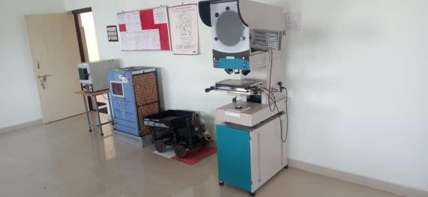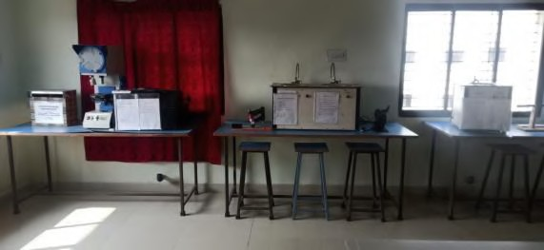Recent Area of Lab (in Sq. Mt.):66

Major Equipments details in a particular lab:

Sr.  No. | Name of Equipments | Quantity
1 | Tool Makers Microscope | 01
2 | Autocollimator | 01
3 | Floating Carriage Micrometer | 01
4 | Screw thread micrometer with Anvil Set | 01

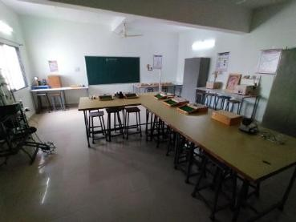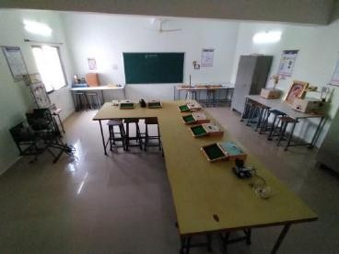

Recent Area of Lab (in Sq. Mt.): 66

Major Equipment’s details in a particular lab:

Sr.  No. | Name of Equipment’s | Quantity
1 | Pressure measurement test rig | 01
2 | Flow measurement test rig | 01
3 | Speed measurement | 01

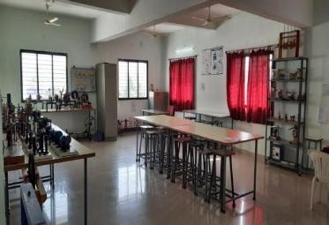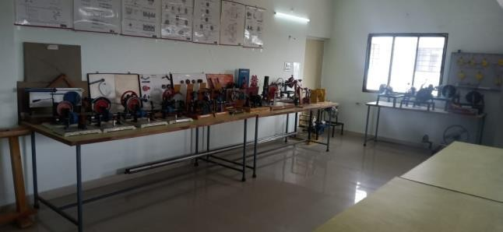

Recent Area of Lab (in Sq. Mt.):66

Major Equipment’s details in a particular lab:

Sr.  No. | Name of Equipment’s | Quantity
1 | Static and Dynamic Balancing Appt. | 1
2 | Whirling Shaft Demonstrator | 1

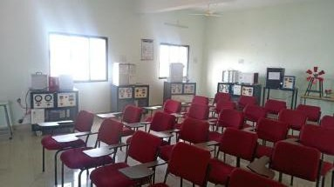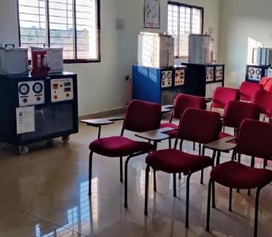

Recent Area of Lab (in Sq. Mt.): 66

Major Equipment’s details in a particular lab:

Sr.  No. | Name of Equipment’s | Quantity
1 | Air Conditioning test rig | 01
2 | Electrolux Refrigerator | 01
3 | Water Cooler test rig | 01
4 | ICE plant trainer | 01
5 | Water to water heat pump | 01

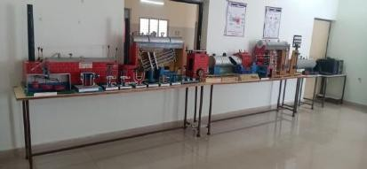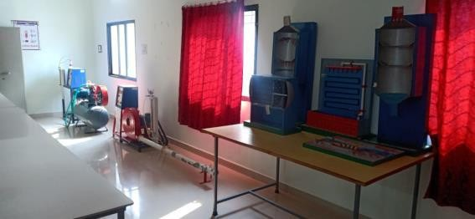
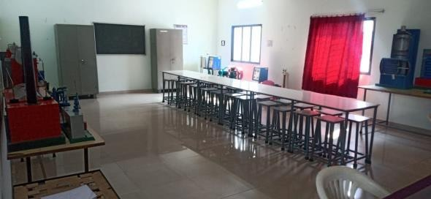

Recent Area of Lab (in Sq. Mt.): 66

Major Equipment’s details in a particular lab:

Sr.  No. | Name of Equipment’s | Quantity
1 | Single Cylinder Air Compressor | 01
2 | Centrifugal Blower test rig | 01

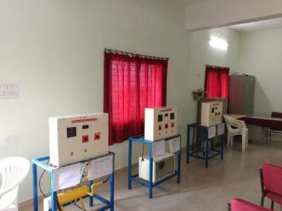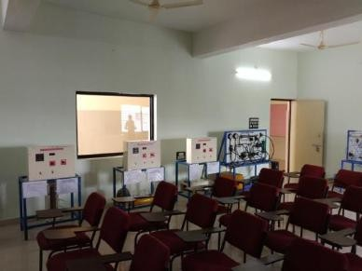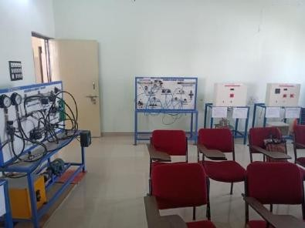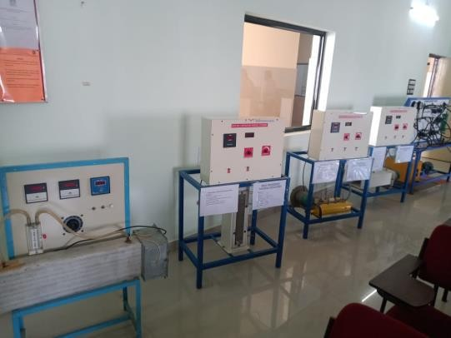

Recent Area of Lab (in Sq. Mt.): 66

Major Equipment’s details in a particular lab:

Sr.  No. | Name of Equipment’s | Quantity
1 | Thermal Conductivity of Metal Rod testing | 1
2 | Emissivity measurement Appt. | 1

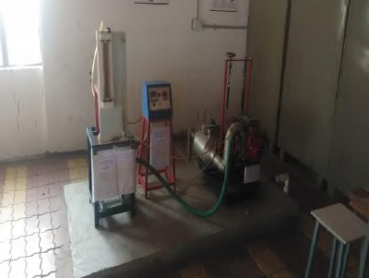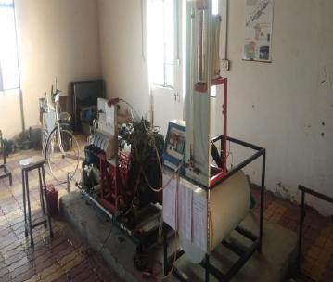

Recent Area of Lab (in Sq. Mt.): 66

Major Equipment’s details in a particular lab:

Sr.  No. | Name of Equipment’s | Quantity
1 | Single cylinder 4 stroke petrol engine test rig | 01
2 | Single cylinder 4 stroke diesel engine test rig | 01
3 | Four cylinder 4 stroke petrol engine test rig | 01

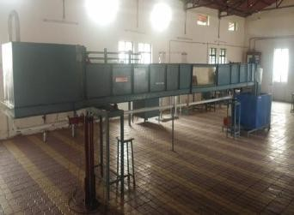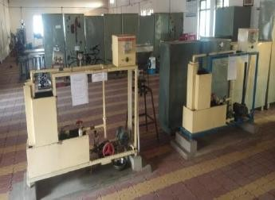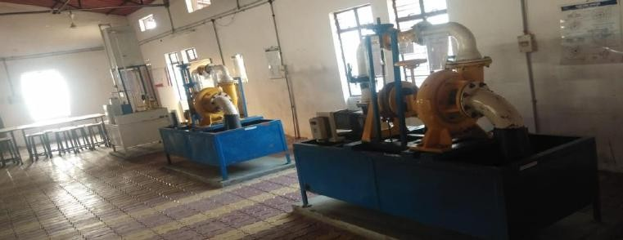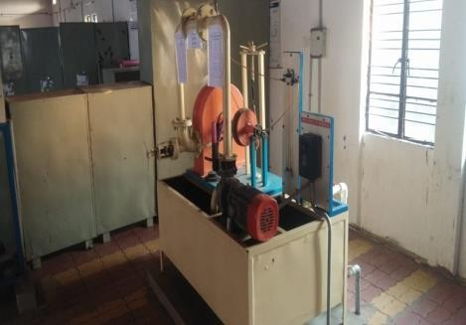

Recent Area of Lab (in Sq. Mt.): 66

Major Equipment’s details in a particular lab:

Sr No | Name of Equipments | Quantity
1 | Pelton Wheel turbine rig | 01
2 | Centrifugal pump test rig | 01
3 | Reciprocating pump | 01
4 | Appratus to find Losses in pipe due to  sudden enlargement | 01
5 | Francis Turbine | 01
6 | Kaplan turbine | 01
7 | Hydraulic Ram | 01
8 | Tilting fume | 01
9 | Appratus to find metacentric height | 01

Name of Lab: Automation Engineering

Most Recent Lab image:
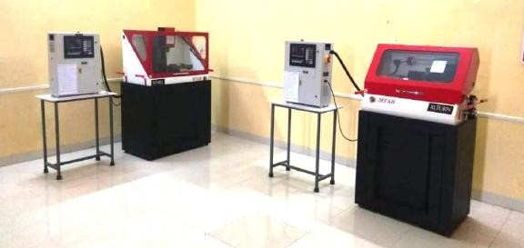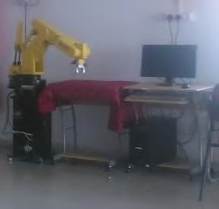
Recent Area of Lab (in Sq. Mt.): 70

Major Equipment’s details in a particular lab:

Sr.  No. | Name of Equipment’s | Quantity
1 | CNC Lathe Machine(XL Turn) | 01
2 | CNC Milling Machine(XL Mill) | 01
3 | Robotic Arm | 01

Name of Lab: CAD Lab

Most Recent Lab image:
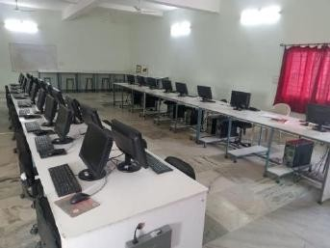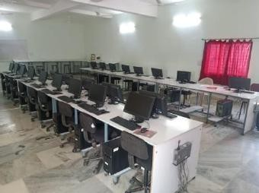
Recent Area of Lab (in Sq. Mt.): 66

Major Equipment’s details in a particular lab:

Sr.  No. | Name of Equipment’s | Quantity
1 | Computers systems | 47
2 | SMPS | 01
3 | Projector | 06
4 | Printer | 05

Department of Civil Engineering

Sr | LAB Name
1 | Surveying-Lab
2 | Strength of Material-Lab
3 | Reinforced Cement Concrete-Lab
4 | Theory of Structure-Lab
5 | Transportation Engineering -Lab
6 | Building Construction & Material-Lab
7 | Engineering Geology-Lab
8 | Environmental Engineering-Lab
9 | CAD-Lab
10 | Geotechnical Engineering-Lab

Name of Lab: Surveying-Lab

Lab images:
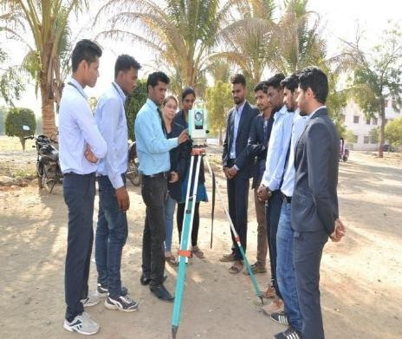
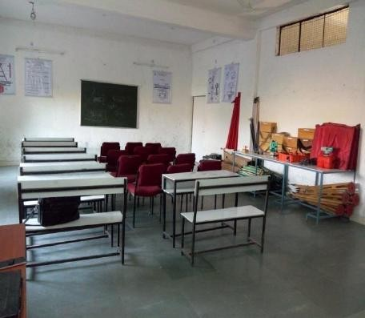

Area of Lab (in Sq. feet): 66 Sq. M.

Equipments details:

Sr. No. | Name of Equipments | Quantity
1 | Automatic Level | 2
2 | Automatic Level (Sokkia) | 4
3 | Cross Staff Optical | 6
4 | Open Cross Staff* | 10
5 | Linoometer compass 3"/Sight | 3
6 | chain - 30 M | 3
7 | Dumpy Level As Per ISI Specification | 5
8 | Electronic Plannimeter | 1
9 | Digitil Plannimeter | 1
10 | Instrument Box | 3
11 | Leveling Staff 5M | 4
12 | Leveling Staff 5M | 5
13 | Metallic Tape 30 M | 3
14 | Measuring Tape 30 M | 3
15 | Measuring Tape 15 M | 3
16 | Measuring Tape (Freeman) 30 M | 10
17 | Optical Squqre (Brass) | 10
18 | Prismatic Compass | 7
19 | Plane Table As Per IS Specification | 5
20 | Plumb Bob | 10
21 | Thedolite | 5
22 | Total Station (Nikon's) | 1

Name of Lab: Strength of Material-Lab
Lab images:
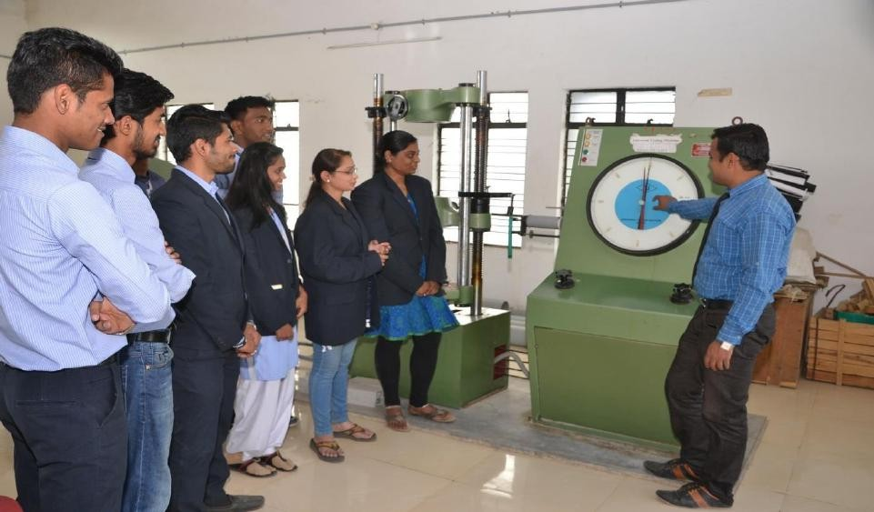

Area of Lab (in Sq. feet): 100 Sq. M

Equipments details:

Sr. No. | Name of Equipment | Quantity
1 | Universal Testing Machine | 1
2 | Mechanical Extensometer | 1
3 | Shear Test Attachment | 1
4 | Impact Testing Machine | 1
5 | Hardness Testing Machine | 1
6 | Spring Testing Machine | 1

Name of Lab: Reinforced Cement Concrete-Lab
Lab images

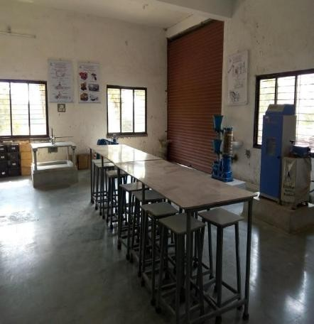: 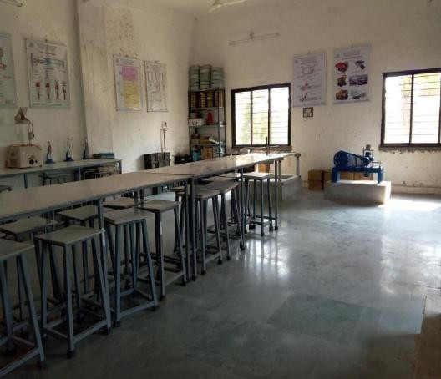
Area of Lab (in Sq. feet) : 66 Sq. M.

Equipments details:

Sr.  No. | Name of Equipment | Quantity
1 | Aimil Digital CTM 2000kN | 1
2 | Rebound Hammer (NDT) | 1
3 | Vibrating Table | 1
4 | Concrete Mixer Machine | 1
5 | Compaction factor instruments apparatus | 1
6 | CI cube mould 7.1x7.1x7.1cm | 6
7 | Cube mould 15x15x15cm | 9
8 | Lee-chartllier appratus (6set) | 3
9 | Mixing tray 200x150x30mm | 6
10 | Measuring jar capacity1lit. | 5
11 | Platform balance capacity 100kg | 1
12 | Pan | 20
13 | Slump cone | 2
14 | Seive shaker machine | 1
15 | Sieve, 90mic , 20cm (Brass) | 2
16 | Sieve 80mm, 63mm, 45mm, 31.5mm , 10mm, 6mm, 4.75mm 2.5mm (Brass) | 1
17 | Shieve 600mic, 300mic, 150mic, with lead and pan 20cm (Brass) | 1
18 | Trowel small | 5
19 | Trowel medium | 5
20 | Trowel large | 5
21 | Vicat apparatus (70x80mm dia) | 2
22 | Vibrating machine | 1
23 | Weight Balance capacity 10kg | 1
24 | Vicat apparatus (70x80mm dia) | 1
25 | Beam Mould 100x100x500 | 1
26 | Beam Mould 150x150x700 | 1
27 | Vernier Calliper 0-150mm | 1
28 | Vernier Calliper 0-300mm | 1
29 | Steel Scale 100cm | 1

Lab images:
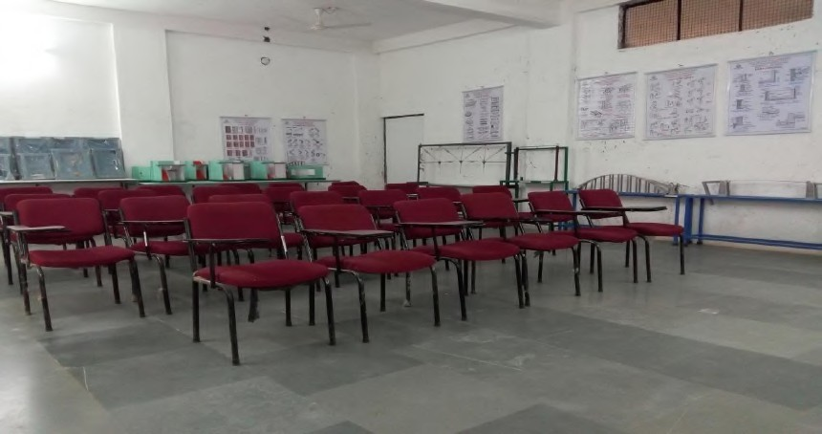
Area of Lab (in Sq. feet): 66 Sq. M.

Equipments details:

Sr.  No. | Name of Equipment | Quantity
1 | Maxwell's Reciprocal Theorem Verification Instrument | 1
2 | Two Hinged Arch Apparatus | 1
3 | Elastic Properties of Deflected Beam Apparatus | 1
4 | Strain Measurement with strain gauge | 1
5 | Portal Frame Apparatus | 1
6 | Deflection of Truss Apparatus | 1
7 | Behavior of Columns & Struts Apparatus | 1

Lab Images:
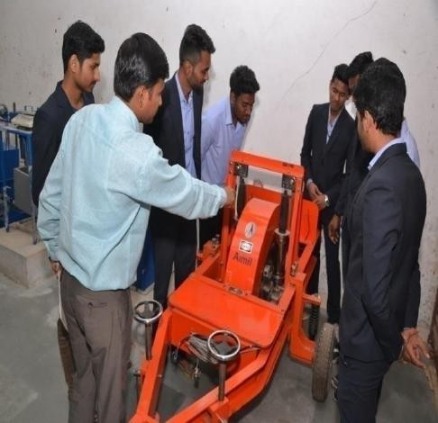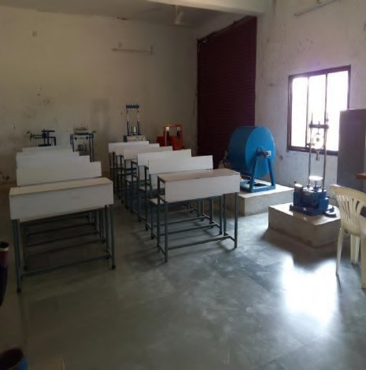
Area of Lab (in Sq. feet): 66 Sq. M.

Equipments details:

Sr.  No. | Name of Equipment | Quantity
1 | Bitumen Penetrometer | 1
2 | Crushing Value Apparatus | 1
3 | Elongation Apparatus | 1
4 | Electronic Balance (300 gm)- ACC 1 mg | 1
5 | Flakiness Index | 1
6 | Hot plate Electric Round Laboratory 8" | 1
7 | Impact Testing | 1
8 | Los Angeles Abrasion Apparatus | 1
9 | Platform balance 5 kg capacity | 2
10 | Softening point Apparatus | 1
11 | Sieve Brass (4.75 mm, 3.3 mm, 2.80 mm, 2.36 mm,2.0 mm, 1.7 mm, 1.4  mm, 1.18 mm, 1 mm, 850µ,710µ,600µ,500µ,425µ,355µ,300µ,250µ,212µ,180µ,150µ) | 20

12 | Sieve Brass (125µ) | 1
13 | Thermometer (Flash and Fire Apparatus) | 1
14 | Thermometer clip for cup | 1
15 | Thermometer | 3
16 | Tar Viscometer | 1
17 | Ductility Testing Machine | 1
18 | Marshall Stability Apparatus | 1
19 | Core Drilling Machine | 1
20 | Benkelman Beam | 1
21 | Bump Integretor | 1
22 | California Bearing Ratio (CBR) Test Appratus | 1
23 | Specific Gravity Balance Appratus | 1

Name of Lab: Building Construction & Material-Lab
Lab images:
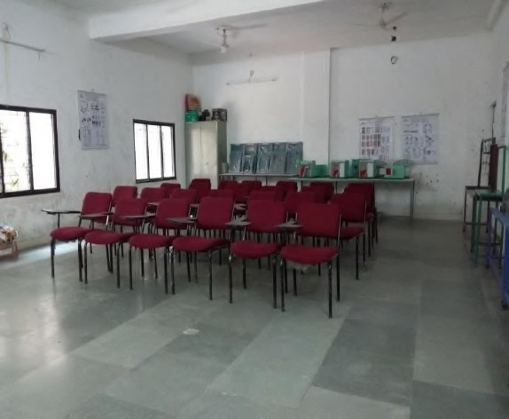
Area of Lab (in Sq. feet): 66 Sq. M.

Equipments details:

Sr. No. | Name of Equipments | Quantity
1 | Models building door with surrounding frame (6 Set) | 1
 | a) Fully Panneled Door | 1
 | b) Half Panneled and Half Glazed Door | 1
 | c) Sash Door | 1
 | d) Ledger and Braced Door | 1
 | e) Flush Door | 1
 | f) Ventained Door | 1
2 | Models building Window (8 Set) | 1
 | a) Louvered or Ventained Window | 1
 | b) Double Hung Window | 1
 | c) Sliding Window | 1

 | d) Casement Window | 1
 | e) Awining Window | 1
 | f) Hopper Window | 1
 | g) Bay Window | 1
 | h) Corner Window | 1
3 | Model of staircase (6 set) | 1

Name of Lab: Engineering Geology-Lab
Lab images:
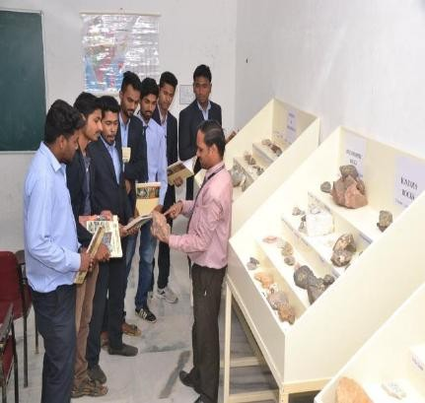
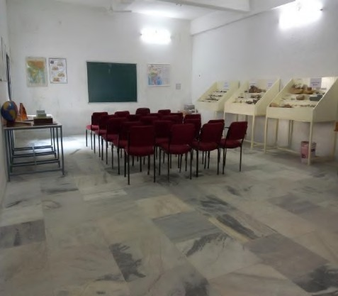
Area of Lab (in Sq. feet) : 66 Sq. M.

Equipments details:

Sr. No. | Name of Equipments | Quantity
1 | Rocks and Mineral Samples | -
2 | Charts of Geology | 8
3 | Geological models | 7
4 | Geological Samples Showcase | 2

Name of Lab: Environmental Engineering-Lab
Lab images:
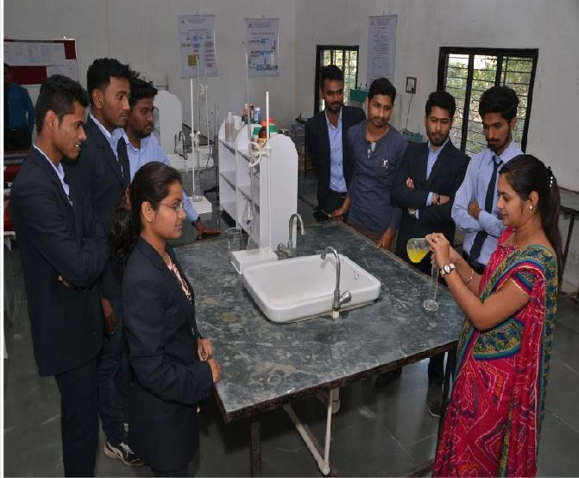
Area of Lab (in Sq. feet): 66 Sq. M.

Equipments details:

Sr. No. | Name of Equipments | Quantity
1 | Thermometer 110 oC | 10
2 | Glass rod | 5kg
3 | GlassTube | 3kg
4 | Test tube Borosil 6x1 | 3 dozens
5 | Test tube Borosil 5x5/8 | 2 dozens
6 | Pair of tongs | 2 dozens
7 | Petri dish | 1/2 dozen
8 | Petri dish | 1.5 dozen
9 | Funnel polythene | 2 dozens
10 | Measuring cylinder 1lit | 2
11 | Measuring cylinder 500ml | 5
12 | Measuring cylinder 100 ml | 5

13 | Measuring cylinder 50 ml | 5
14 | Measuring cylinder 10ml | 10
15 | Burret 50 ml Boroflow ; (Borosil) | 50
16 | Glass Beaker 1lit NG | 5
17 | Glass Beaker 1lit borosil | 5
18 | Polythene Beaker 1lit | 5
19 | Glass Beaker 500 ml NG | 5
20 | Glass Beaker 500 ml Borosil | 5
21 | Polythene Beaker 500ml | 5
22 | Glass beaker 250 ml NG | 7
23 | Glass beaker 250 ml Borosil | 7
24 | Polythene 250 ml | 10
25 | Glass beaker 100ml NG | 10
26 | Glass beaker 100ml Borosil | 10
27 | Conical flask 250ml NG | 10
28 | Conical flask 250ml Borosil | 10
29 | Conical flask 100ml NG | 10
30 | Conical flask 100ml Borosil | 10
32 | Pippette Graduated 10 ml | 40
33 | Pippette Graduated 25ml | 10
34 | Reagent container (5litre) | 10
35 | Reagent container (10litre) for distilled water | 5
36 | Reagent bottle 500ml Narrow mouth N.G. | 30
37 | Burret stand (size 225 x150mm) | 10
38 | Burret stand (size 225 x150mm) clamp | 10
39 | Volumetric flask 100ml NG | 5
40 | Volumetric flask 100ml Borosil | 5

Lab images:
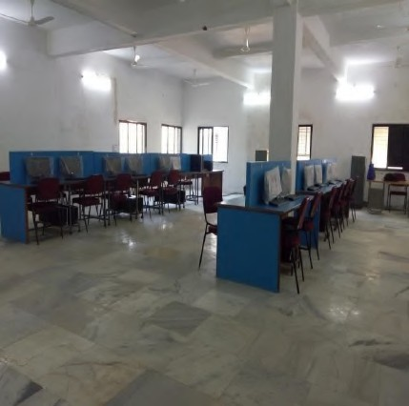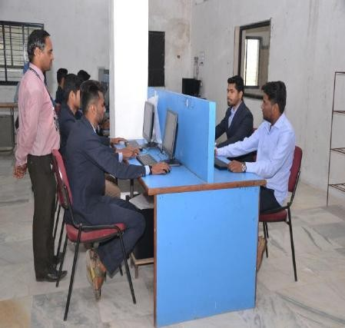

Area of Lab (in Sq. feet): 132 Sq. M.

Equipments details:

Sr.  No. | Name of Equipments | Quantity
1 | Computers | 26

Lab images:
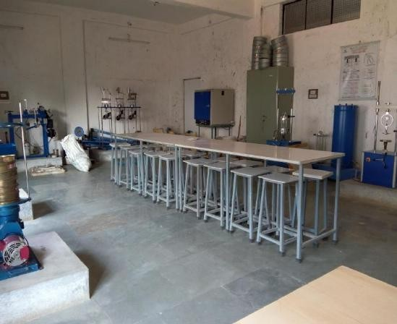

Area of Lab (in Sq. feet): 66 Sq. M.

Equipments details:

Sr. No. | Name of Equipment | Quantity
1 | Consolidation Test Equipment | 1
2 | Soil Permeability Test Equipment | 1
3 | Liquid Limit Kit Hand | 2
4 | Plastic Limit Kit | 2
5 | Shrinkage Limit Kit | 2
6 | Core Cutter Appartus | 1
7 | Unconfined Compression Test (Electric) | 1
8 | Galvnised Iron Tray (10" X 12") | 1
9 | Galvnised Iron Tray (12" X 15") | 1
10 | Seive Brass Frame 20 cm dia | 1
11 | Moisture container box size (2" X 1") | 1

12 | Pycnometer with Stirrer | 2
13 | Stop Watch Digital | 2
14 | Compaction Mould with Base | 1
15 | Electronics balance 20 kg capacity | 1
16 | Electric oven (45 X 45 X 45 cm) | 1
17 | Standard Penitration Test | 1
18 | Triaxial compression test apparatus | 1
19 | Direct Shear Test Apparatus | 1
20 | Hand Operated sampling outfit | 1
21 | Grain Size Appratus by Seiving Method | 1
22 | Alluminium Moisture Box (2" X 2") | 10
23 | Seive Set G.I. and Brass | 1
24 | Rapid Moisture Meter | 1
25 | Plate Bearing Test | 1
26 | Vane Shear Test | 1
27 | Extractor frame universal | 1
28 | Set of Weights | 1

Department of Computer Science & Engineering

Sr. No. | LAB Name
1. | Computer Center Lab
2. | Web Technology Lab
3. | Data Structure Lab
4. | Operating System Lab
5. | Hardware Lab
6. | DBMS Lab
7. | Software Lab

Name of Lab: Web Technology Lab
Most Recent Lab images:

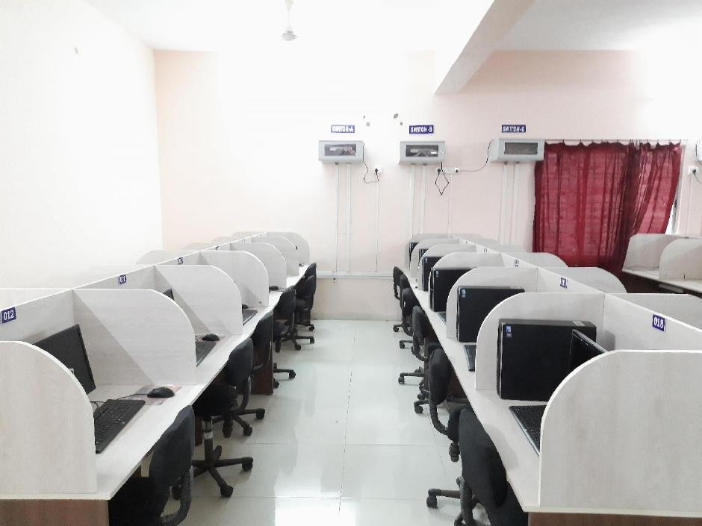
Recent Area of Lab (in Sq. Mt.): 66
Major Equipments details in a particular lab:

Sr. No. | Name of Equipments | Quantity
1. | PC | 20
2. | UPS | 1
3. | Switch | 2

Name of Lab: Data Structure Lab
Most Recent Lab images:

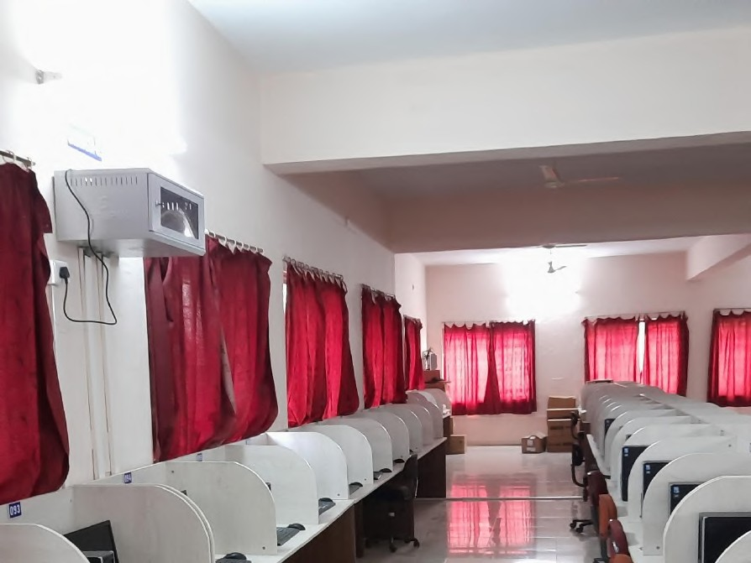

Recent Area of Lab (in Sq. Mt.): 66
Major Equipments details in a particular lab:

Sr. No. | Name of Equipments | Quantity
1. | PC | 20
2. | UPS | 1
3. | Switch | 2

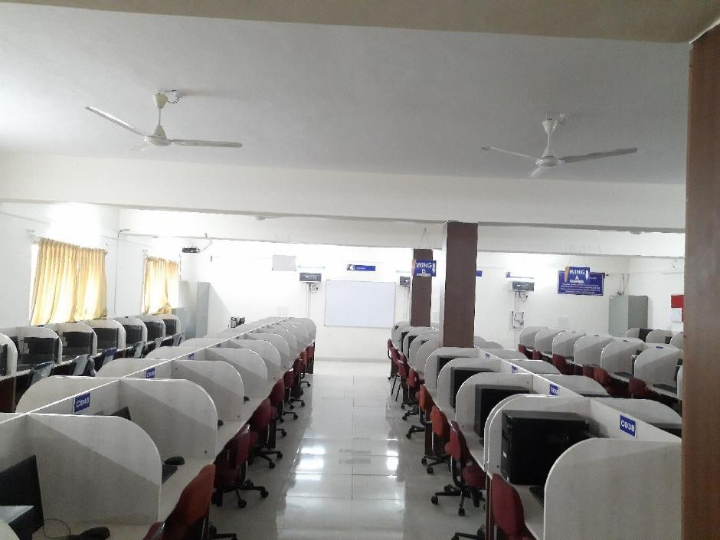

Recent Area of Lab (in Sq. Mt.): 66
Major Equipments details in a particular lab:

Sr. No. | Name of Equipments | Quantity
1. | PC | 20
2. | UPS | 1
3. | Switch | 2

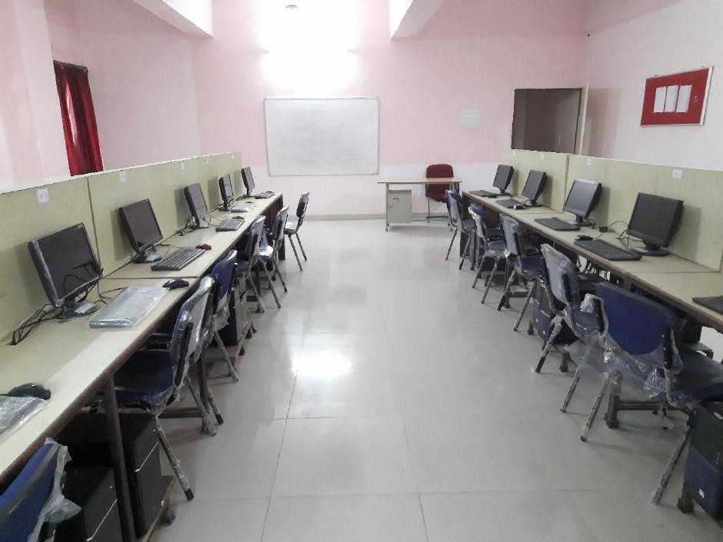

Recent Area of Lab (in Sq. Mt.): 66
Major Equipments details in a particular lab:

Sr. No. | Name of Equipments | Quantity
1. | PC | 20
2. | UPS | 1
3. | Switch | 2

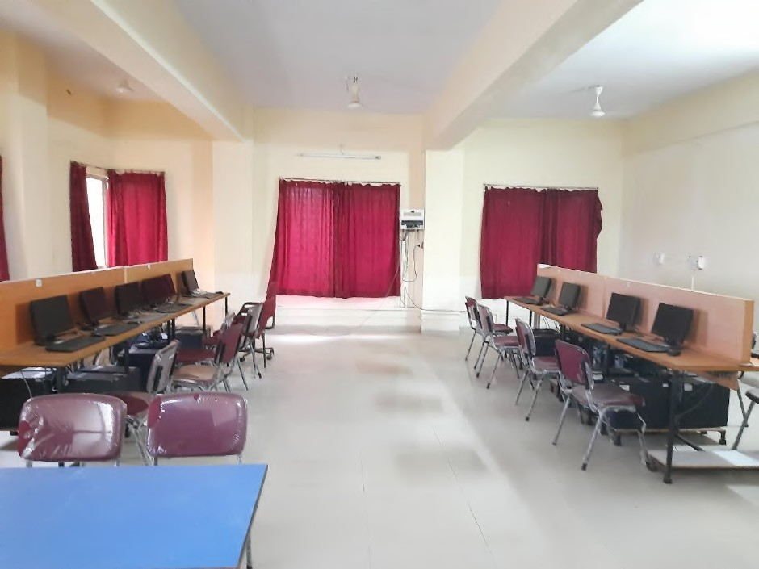

Recent Area of Lab (in Sq. Mt.): 66
Major Equipments details in a particular lab:

Sr. No. | Name of Equipments | Quantity
1. | PC | 20
2. | UPS | 1
3. | Switch | 2

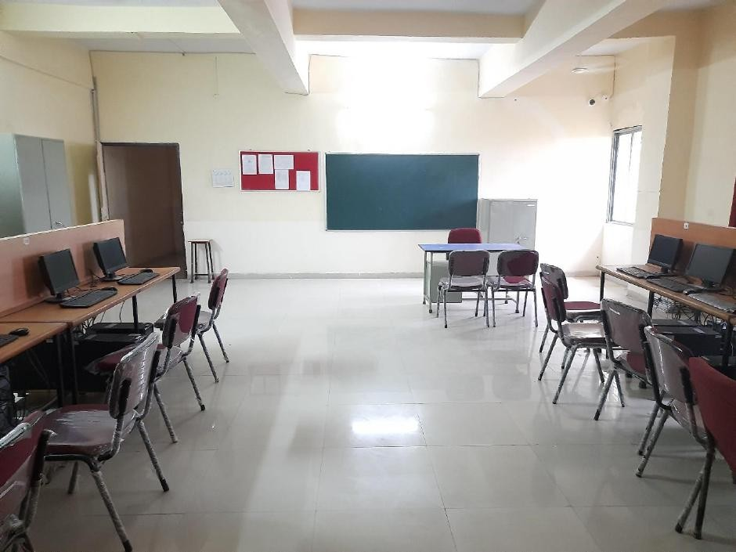

Recent Area of Lab (in Sq. Mt.): 66
Major Equipments details in a particular lab:

Sr. No. | Name of Equipments | Quantity
1. | PC | 20
2. | UPS | 1
3. | Switch | 2

Department of Electronics & Telecommunication Engineering

Department LAB Names:-

Sr. No. | LAB Name
1 | Electronic Circuit Lab
2 | Instrumentation & Control Lab
3 | Simulation Lab
4 | Switching & Digital Lab
5 | Communication & Microwave Lab
6 | Electrical Machine Lab
7 | Hardware Lab
8 | Research Lab
9 | PG Lab

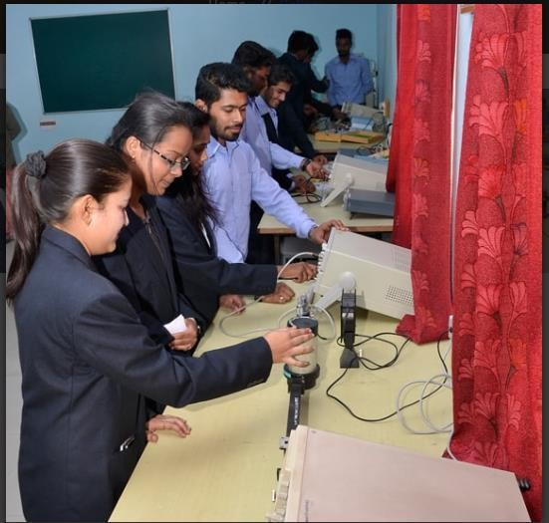
Most Recent Lab images:
Recent Area of Lab (in Sq. Mt.):75 Sq.Mt Major Equipments details in a particular lab:
Sr. No. | Name of Equipments | Quantity
1 | Klystron bench | 2
2 | Gunn bench | 2

Most Recent Lab images:
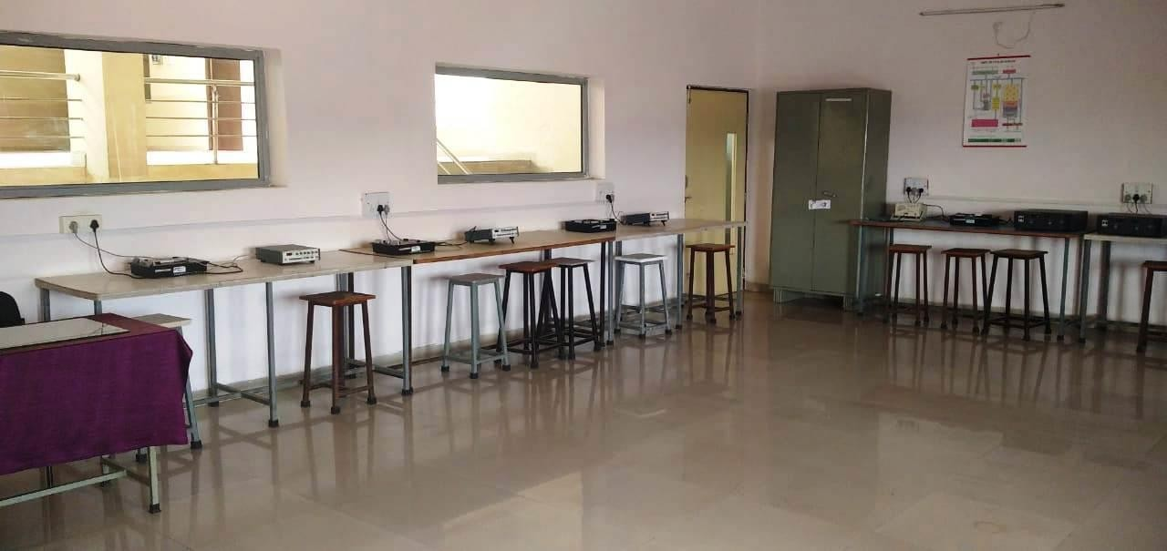

Recent Area of Lab (in Sq. Mt.): 75
Major Equipments details in a particular lab:

Sr.  No. | Equipment Name | Quantity
1 | Cathode ray Oscilloscope(C.R.O)20Mhz scientech make:caddo 801 | 3
2 | Signal Generator scientech make caddo 1500 | 1
3 | ADC &DAC module IM-09 &IM-10 | 2
4 | Digital IC tester scientech make LP-01 | 1
5 | Microcontroller Development board with Programmer NV5001 | 2
6 | Multiplexer 16:1(ST 302) | 1

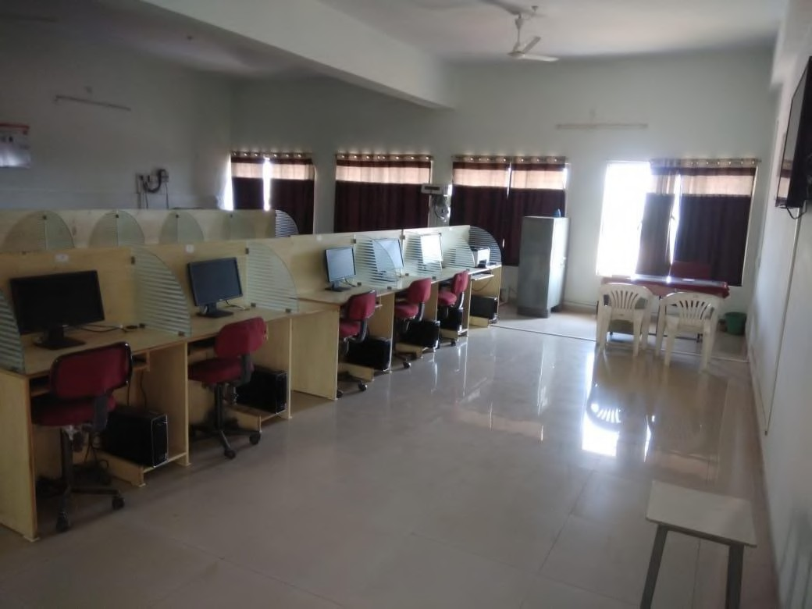
Most Recent Lab images:

Recent Area of Lab (in Sq. Mt.):77 Sq.Mt

Major Equipments details in a particular lab:
Sr. No. | Name of Equipments | Quantity
1. | Microwind3.8 Software tool for VLSI design and  Simulation Lab | 10 copies

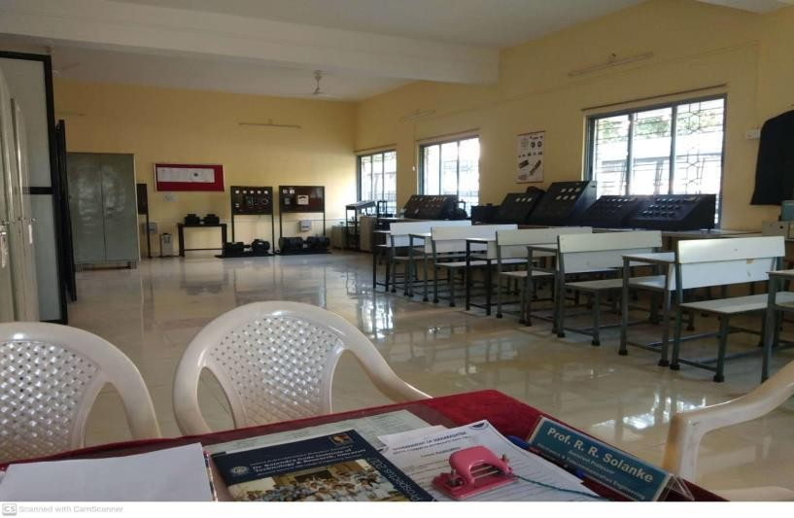
Most Recent Lab images:
Recent Area of Lab (in Sq. Mt.): 75 sq meter Major Equipments details in a particular lab:
Sr. No. | Name of Equipments | Quantity
1 | D.C Motor (Lab 1&Lab 2) | 2
2 | A.C.Motor | 2
3 | Motor Generator Set | 2
4 | Rectifier unit | 2

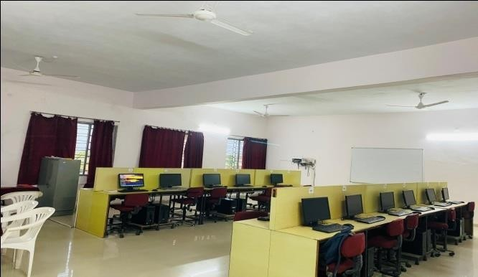
Most Recent Lab images:

Recent Area of Lab (in Sq. Mt.):75 Sq. Mt. Major Equipments details in a particular lab:

Sr. No. | Equipment Name | Quantity
1 | Wipro Branded Machine | 22
2 | Samsung ML-1610 Laser Printer | 1
3 | ESCAN Antivirus | 1
4 | HP-8X External Slim  Multiform at DVD/CD Writer | 1
5 | Emerson PB 6KVA UPS | 1
6 | D-Link 24 Port Switch | 1
7 | D-Link Cable | 1
8 | D-Link RJ 45 Connector | 56
9 | HP Desktop Dual Core | 13

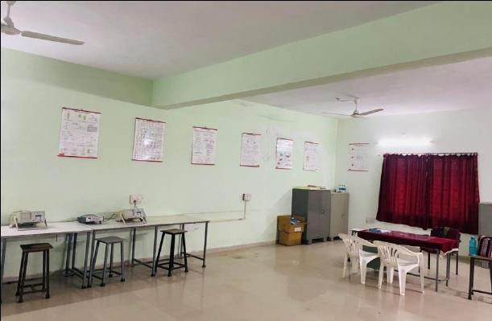
Recent Area of Lab (in Sq. Mt.):75 Sq. Mt.

Major Equipments details in a particular lab:
Sr.  No. | Equipment Name | Quantit y
1 | LDR Kit ( SA -107) | 1
2 | Soldering & Desoldering Pratice Tranier Kit | 1
3 | Display board of SCR,DIAC,TRIAC.UJT | 1
4 | LVDT - Kit ( Omega make ) ICI-901 | 1
5 | Measurment of Strain using strain gauge ( SE 1007 ) | 1
6 | Temp Trausducer trainer Kit ( ST- 2302) | 1
7 | Disreat Component trainer board | 1
8 | Water Level measurment Trainer Kit ( ST 2309) | 1
9 | Instrumention Emplifier by Omega Model -ETB-218 | 1
10 | SCR Stepup Chopper Kit Circuit | 1
11 | SCR Commutation Circuit Scientech : Model : ST -2717 | 1
12 | SCR Characterstics Kit ( SA -401) | 1
13 | Inverter Bedford & Parallel Inverter Ckt Scientech Model : ST 2718 | 1
14 | CRO : 20 MH Scinentech Make Caddo 801 | 2
15 | Function Genertor ( 2 MH ) with Standard accessories | 5

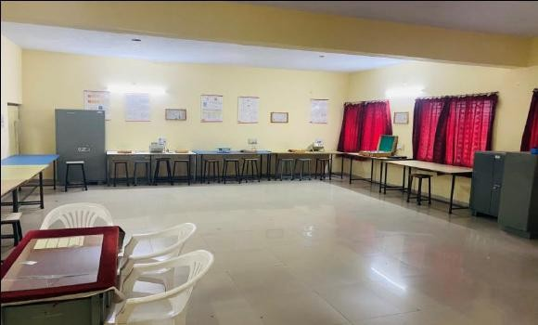

Recent Area of Lab (in Sq. Mt.):75 Sq. Mt.

Major Equipments details in a particular lab:

Sr. No. | Name of Equipments | Quantity
1 | Digital storage oscilloscope | 1

Department: Applied Science and Humanities
Department LAB Names:-

Sr. No. | LAB Name
1 | Engineering Physics
2 | Engineering Chemistry
3 | Engineering Mechanics
4 | Electrical Engineering

Name of Lab: Engineering Physics
Most Recent Lab images:
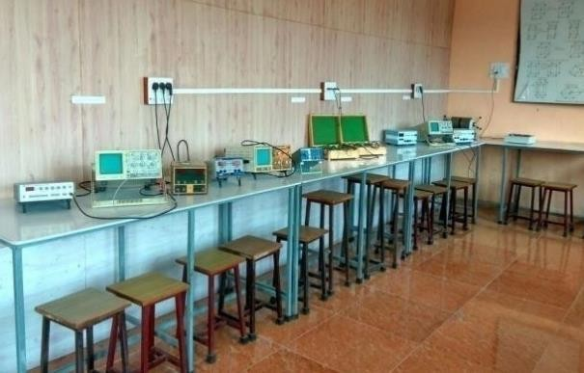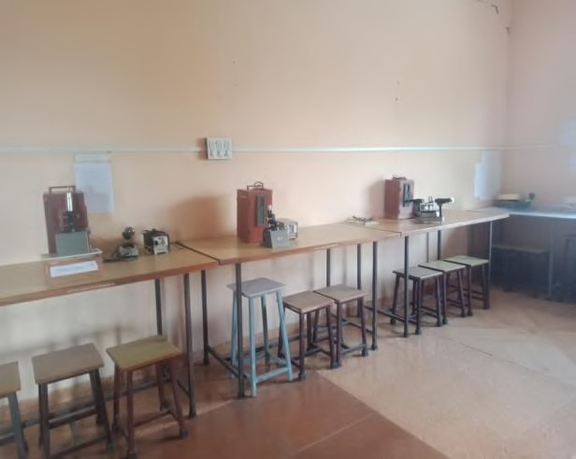
Recent Area of Lab (in Sq. Mt.): 67
Major Equipments details in a particular lab:

Sr. No. | Name of Equipments | Quantity
1 | Cathode Ray Oscilloscope (CRO) Aplab | 3
2 | E/M by bar magnet method complete set up | 1
3 | Four probe method apparatus | 1
4 | He - Ne Laser gun Complete Set Up 2MW | 1
5 | Newton’s Ring apparatus with microscope complete | 2
6 | Sodium vapour lamp transformer with box and  Transformer (Set) | 3
7 | Spectrometer 7” Steel Scalate | 2
8 | Junction Diode Characteristics Apparatus | 4
9 | Hall Effect Complete Set Up | 1

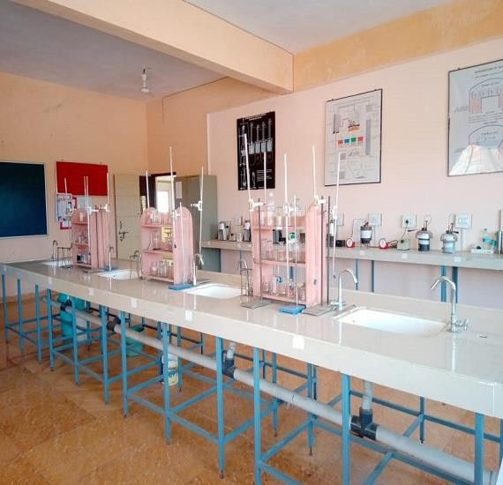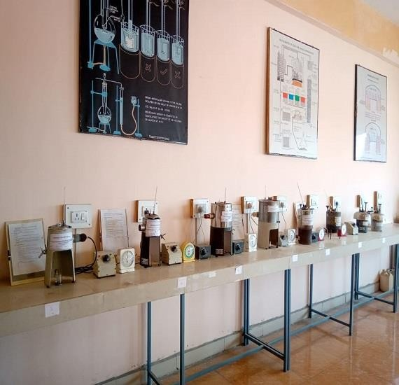
Recent Area of Lab (in Sq. Mt.): 70
Major Equipments details in a particular lab:

Sr. No. | Equipment Name | Quantity
1 | Abel's Flash Pt.App | 2
2 | Conductivity Meter | 2
3 | Digital Balance | 1
4 | Hot Plate | 2
5 | Muffle Furnace | 1
6 | Oven | 1
7 | Pensky-Marten Flash Pt | 2
8 | pH METER | 2
9 | Redwood Viscometer No.1 | 2
10 | Redwood Viscometer No.2 | 2

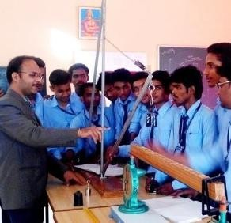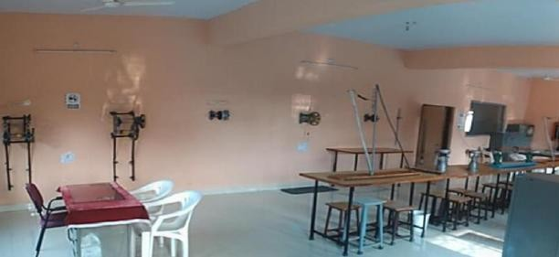

Recent Area of Lab (in Sq. Mt.): 70

Major Equipments details in a particular lab:

Sr. No. | Name of Equipments | Quantity
1 | Single Purchase Crab Winch | 1
2 | Double Purchase Crab Winch | 2
3 | Flatchers Trolley | 1
4 | Simple Lifting Machine | 2
5 | Simple Zip Crane | 2
6 | Belt Friction Apparatus | 2
7 | Share Leg Apparatus | 1
8 | Fly Wheel With Counter | 1
9 | Simple Supported Beam(Dial Type) | 1
10 | Differential Axel Wheel | 1

Events and Activities held in our College
RHYTHM Celebration
We celebrates ASG(Annual Social Gathering) known as RHYTHM that marked the beginning of a new innovative tradition of bringing all types of technical as well as cultural activities under one roof.

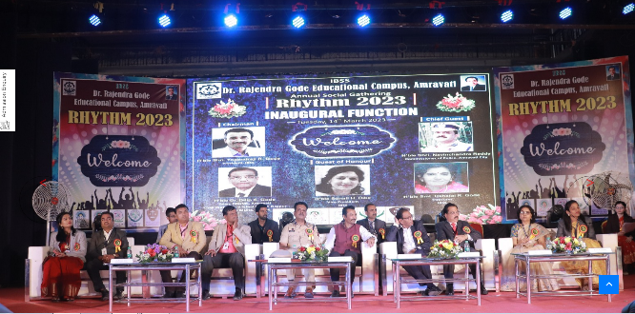

NSS

Dr.Rajendra Gode Institute of Technology & Research has a very active and dedicated NSS unit. The NSS unit was inaugurated by the hands of Hon’ble Vice-Chancellor Dr. Kamal Singh on 15-01-09. The total strength of this unit is of 100 students.
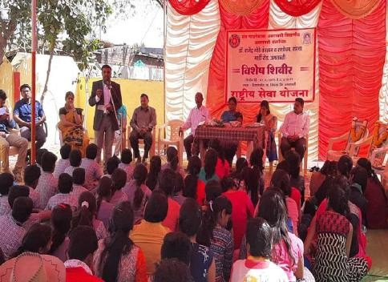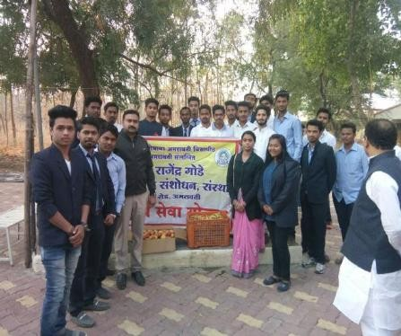

The unit was inaugurated by the hands of Hon'ble Dr.Kamal Singh , Vice Chancellor, S.G.B Amravati University, Amravati. President of I.B.S.S , Buldana Dr.Rajendraji Gode. Director of students welfare Dept., Dr.Shrikant Patil , Shri R.S.Kadam , D.F.O. Amravati Forest Division were the chief-guests for the function. Prof.S.D.Thakre is working as the programme officer of the N.S.S unit. DRGIT&R College of Engineering has a very active and dedicated NSS unit of 150 volunteers. The NSS unit was conducted many social program at Andha Vidyalaya, Madhuban Vruddhashram and primary school at Masod. The NSS unit was arrange many awareness program like street plays, rallies etc. Nss unit also arrange Free Medical Check Up Camp at Masod & Madhuban Vruddhashram, it also conducted NSS special camp at Masod. All these activities were appreciated by Dr. Mohan Khedkar, Vice-Chancellor of SGBAU Amravati & Dr. Shrikant Patil, Coordinator of NSS, SGBAU Amravati. The unit has been regularly involved in various social activities like Plantation, Blood Donation, taking educational resources to the door of poor and deprived. This also helps to create social awareness in the students and for the development of their personalities.

SPORTS
DRGIT&R provides excellent facilities and encourage the students to take active part in tournaments held in and around Amravati University, Also celebrate the sport week at the time of ASG(Annual Social Gathering).

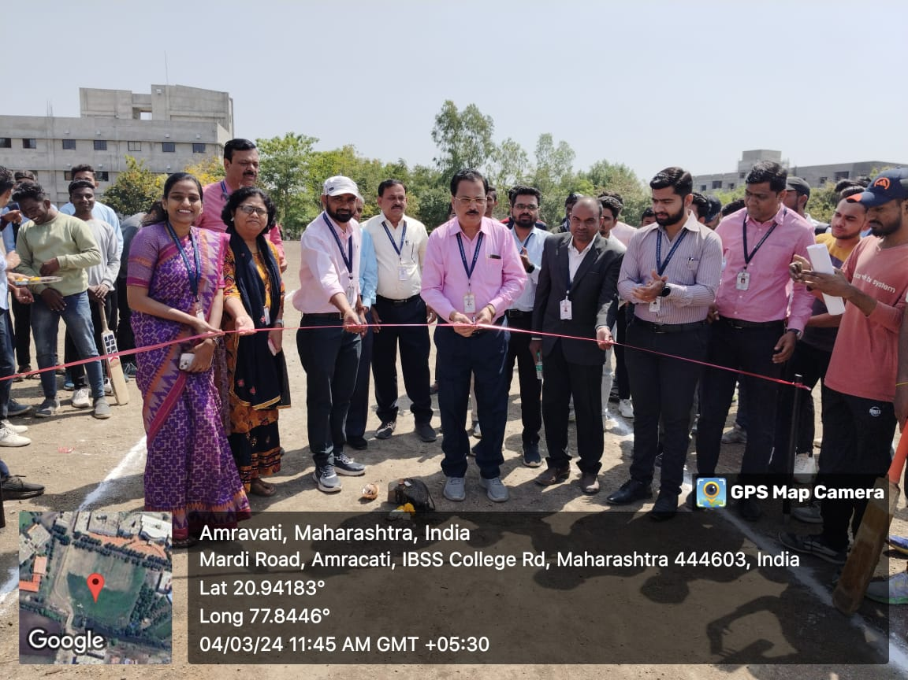
Youth Festival 2023
Our institute participated in youth Festival 2023 which was organized by SGBAU held at Chikhali.
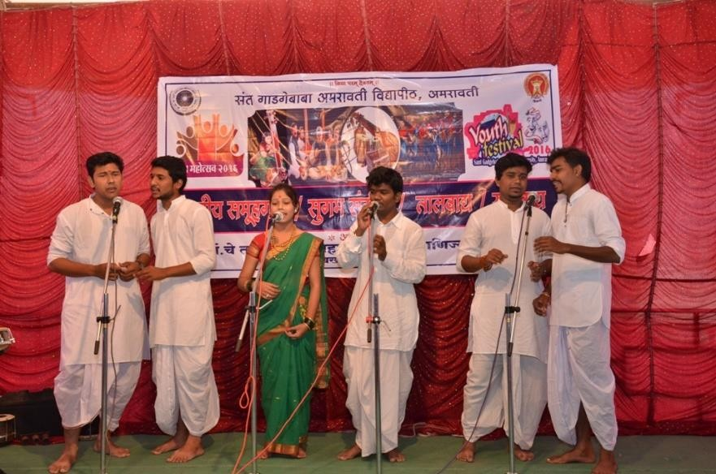

Other Facilities:-
College Library | 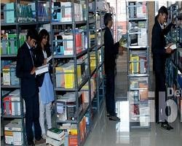
College Bus | 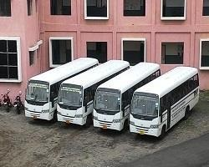
Medical Facility & Ambulance | 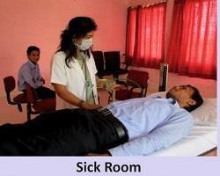

24X7 High Speed Wireless Internet | 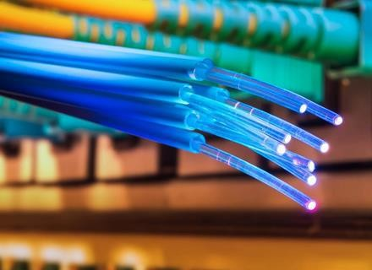
Parking Facility | 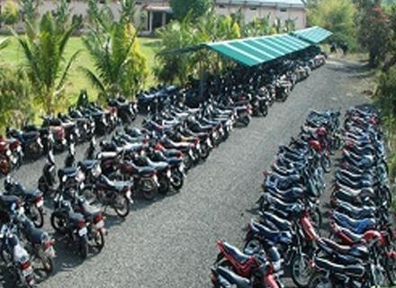
Canteen Facility | 